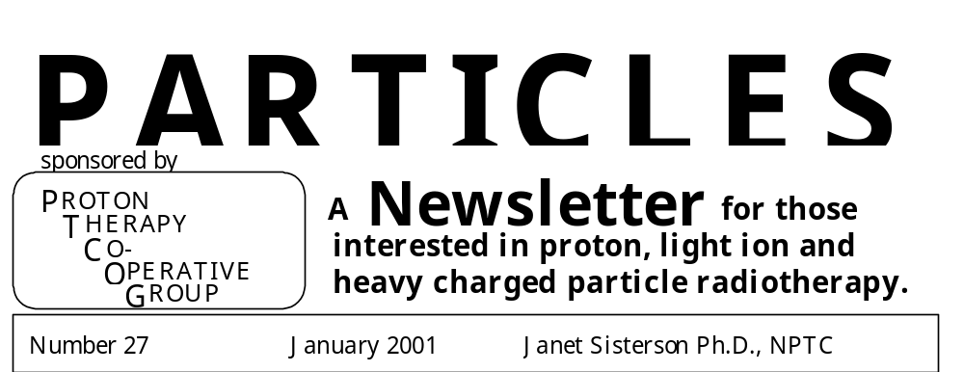

Costs: At PTCOG XIX, the Steering Committee decided that part of the registration fee for PTCOG meetings would be used to help produce both Particles and the abstracts of the PTCOG meetings. Only part of the costs is covered in this way, so more financial help is needed from the community. PTCOG is always happy to receive financial gifts; all such gifts are deductible as charitable contributions for federal income tax purposes. The appropriate method is to send a check made out to the “Massachusetts General Hospital” and sent to Janet Sisterson at the address given below.

Facility and Patient Statistics: I continue to collect information about all operating or proposed facilities. Please send me your information. My latest published summary of the worldwide detailed patient statistics through 1997 is:
“World wide proton therapy experience in 1997.” Author: J. M. Sisterson. CP475, Application of Accelerators in Research and Industry, eds. J. L. Duggan and I. L. Morgan, AIP Press, New York (1999), p959-962. Copies available on request.

Particles on the Internet: The URLs for the Harvard Cyclotron Laboratory, which contain links to PTCOG and Particles are:
- http://neurosurgery.mgh.harvard.edu/hcl/ or http://brain.mgh.harvard.edu:100/hcl

Other proton therapy links:
- Northeast Proton Therapy Center: http:// www.mgh.harvard.edu/depts/nptc/nptc.htm
- LLUMC, California: : http://proton.llu.edu
- U of California, Davis: http://crocker.ucdavis.edu/cnl/research/eyet.htm
- Midwest Proton Radiation Institute: http://www.iucf.indiana.edu
- National Association for Proton Therapy: http://www.proton-therapy.org
- TRIUMF, Canada; protons: http://www.triumf.ca/welcome/proton_thrpy.html
- TRIUMF, Canada; pions: http://www.triumf.ca/welcome/pion_trtmt.html
- CPO, Orsay, France: http://www-sop.inria.fr/epidaure/personnel/bondiau/CPO_base/cpo_base.htm
- PSI, Switzerland: http://www.psi.ch/
- TERA foundation, Italy: http://www.tera.it
- Catania, Italy: http://lnsuni2.lns.infn.it/~catana/
- GSI homepage: http://www.gsi.de
- The Svedborg Laboratory, Sweden: http://www.tsl.uu.se
- Clatterbridge Centre for Oncology: http://synaptic.mvc.mcc.ac.uk/simulators.html
- Rinecker Proton Therapy Center, Munich, Germany: http://www.rptc.de
- ITEP, Moscow, Russia: http://www.protontherapy.itep.ru
- Tsukuba, Japan: http://www-medical.kek.jp
- Tsukuba, Japan - new facility plans: http://www-medical.kek.jp/devnewfac.html
- HIMAC, Chiba, Japan: http://www.nirs.go.jp/ENG/particl.htm (ENG case sensitive)
- NAC, South Africa: http://medrad.nac.ac.za/index.htm

ARTICLES FOR PARTICLES 28

June 30 2001 is the deadline for news for Particles 28, the July 2001 issue. Address all correspondence for the newsletter to:

Janet Sisterson Ph.D. Telephone: (617) 724-1942
Northeast Proton Therapy Center Fax: (617) 724-9532
Massachusetts General Hospital E-mail: jsisterson@partners.org
30 Fruit Street, Boston MA 02114

Articles for the newsletter should NOT exceed two pages in length.

PTCOG BUSINESS and FUTURE PTCOG MEETINGS

Chair: Michael Goitein | Secretary: Janet Sisterson
Department of Radiation Oncology  Massachusetts General Hospital  Boston MA 02114 | Northeast Proton Therapy Center  Massachusetts General Hospital  Boston MA 02114

Steering Committee Members
USA | Europe | Russia | Japan | South Africa
W. Chu | U. Amaldi | V. Khoroshkov | K. Kawachi | D. Jones
M. Goitein | H. Blattmann |  | H. Tsujii
D. Miller | J.-L. Habrand
J. Sisterson | G. Goitein
James Slater | E. Pedroni
A. Smith | A. Wambersie
H. D. Suit
L. Verhey

The times and locations of the next PTCOG meetings are as follows:

PTCOG XXXIV | Boston, MA, USA | June 11-13 2001
PTCOG XXXV | Tsukuba, Japan | November 14-16 2001

We are actively seeking hosts for future PTCOG meetings. PTCOG meetings rotate around the world with the approximate schedule of North America, Europe, elsewhere in the World. We do have a few tentative hosts/dates for meetings after 2001 but we need more. We will entertain offers from both operating facilities and those groups seriously considering building a proton or ion therapy facility. Please contact Janet Sisterson in writing (e-mail, fax or ‘snail mail’) with possible dates and indicate why it would be important to you to host a PTCOG meeting at your chosen time.

Summary of the Steering Committee Meeting,
PTCOG XXXIII
September 26 2000, Berlin, Germany.

Attendees included: A. Smith, J. Sisterson, W. Chu, H. Blattmann, E. Pedroni, H. Tsujii, H. Kluge, J. Heese, Y. Akine, J. Wilson, R. Schulte.

Future PTCOG meetings
The next PTCOG meeting in Boston, June 11-13, 2001.
- NO parallel sessions. Strong feelings that physicians should listen to physics talks and vice versa.
- The clinical protocol session should include multi-modality protocols.
- Not a lot of enthusiasm for a workshop. Very little for one on dosimetry. Recommend NO workshop.
- Would like a session called “The technology of intensity modulated protons”.
Tsukuba, Japan Nov 14-16 2001
- The dates are fixed and cannot be changed.
- There is limited hotel accommodation in Tsukuba and busses will be provided.
- There should be a session on QA, because this is very important.
- Clinical topics should include those important in Japan.
Future meetings:
- NAC, South Africa will definitely like to host a meeting in the future. This should not be the next meeting after the Tsukuba meeting because of the expense involved.
- We need to solicit sites for future PTCOG meetings, so that we can maintain the rotation of the PTCOG venues.

The future of PTCOG
This discussion lasted about an hour and a half. It was a very good discussion and the Steering Committee came up with a strong set of recommendations to be implemented before the Boston PTCOG meeting, if possible.

The Steering Committee Recommendations are:
Funding
- There was much discussion about instituting dues, but the consensus was to stay with what we are doing now, which is using part of the registration fees to fund Particles and PTCOG.
- At PTCOG meetings there should be student registration rates and the organizers should try to arrange for reasonably priced student accommodation.
- We should seek help from our commercial members. One suggestion was to establish student travel awards, so that we can set up a ‘student travel fund’. These awards need not be large. A student could be awarded “the company X Travel Award”. The recipients of these awards could be listed in Particles.

Steering Committee format:
- The changes will implemented before the Boston PTCOG meeting, when the new Steering Committee will elect a new chairperson.
- The chairperson will serve a single, 3 year term
- Every 3 years, ‘the future of PTCOG’ will be re-examined and the Steering Committee re-aligned if necessary.
- It was agreed that the Secretary of PTCOG and the editor of Particles would stay one and the same – Janet Sisterson.
- Each operating (and those soon to be operating – defined as having a hole in the ground and more concrete in it than can be poured by amateurs over a weekend) can elect a member to serve on the Steering Committee. The institutions in question will be contacted in the near future and asked to respond in writing with the name of their member elected to the Steering Committee.
- A long-term active facility that is now closed –such as Berkeley - may also elect a member to serve on the Steering Committee. The Chairman and Secretary added this after considering the suggestion from the General “Future of PTCOG session”.
- If the elected member cannot attend a meeting, a substitute may attend in their stead.
- BUT if the elected member misses many consecutive Steering Committee meetings, they should be asked to resign and appoint a successor who would be better able to attend the meetings.
- No closed meetings, all may attend, but observers would have limited opportunity to speak.

Frequency and location of meetings:
- Stay with meetings twice a year, it’s a format that works
- Revisit this topic in 3 years.
- There were a lot of very positive feelings expressed about the value of the PTCOG meetings. These opinions came from both physicists and physicians.
- The location format of a rotation of North America, Europe and elsewhere in the world is liked.

General “Future of PTCOG session”
- This session was well attended.
- The recommendations of the Steering Committee were presented
- There was little discussion and the comments to be considered were to be in writing and signed.
- Only written suggestion was from Jon Slater who rightly pointed out that by limiting the Steering Committee members to be from operating or soon-to-be-operating centers we would eliminate people who otherwise would be good committee members.

PTCOG XXXIV
Boston, MA, USA
June 11-13 2001

PTCOG XXXIV will be hosted by the Northeast Proton Therapy Center (NPTC) at Massachusetts General Hospital (MGH) from June 11 – 13 2001.
NPTC is located on the main MGH campus in the grounds of the former Charles Street Jail. The mailing address, e-mail address and fax numbers for NPTC are as follows:

Northeast Proton Therapy Center
Massachusetts General Hospital
30 Fruit Street
Boston MA 02114, USA
Fax: 617 724 9532
e-mail: ptcog@partners.org
Please use the above e-mail address for all questions. The registration form is included in this mailing.
The local organizing committee is led by Michael Goitein and Janet Sisterson.

Registration: The registration fee will be $250. The student registration fee is $150. To receive the student rate, a letter verifying your status at the time of registration is required. Payment can be in the form of cash, Travelers checks or personal checks in US$. Checks should be made out to “Massachusetts General Hospital”. We regret that we cannot accept payment by wire transfers or credit cards.
Meeting Venue: All oral sessions, poster presentations and industrial exhibits will be held at the Holiday Inn adjacent to the MGH campus, which is a short walk from the Charles/MGH T-stop. We do not encourage the use of private cars because there is very limited parking available at the Holiday Inn. Free MGH shuttle busses run from the Charlestown Navy Yard (near the YMCA) to the main MGH campus at frequent intervals throughout the day.
Accommodation: Hotel rooms are very hard to find in Boston and are very expensive. We have reserved blocks of rooms at the following hotels for Sunday through Tuesday nights. Please contact the hotels directly and mention that you are attending the PTCOG meeting to get the hotel prices quoted below. We encourage you to make your reservations as soon as possible. If rooms are not available at these hotels, please contact the PTCOG organizers for a list of other convenient hotels.

Holiday Inn (Government Center) John Jeffries House Armed ServicesYMCA/Constitution Inn
5 Blossom Street 14 Embankment Road 150 Second Ave
Boston MA 02114 Boston, MA 02114 Charlestown, MA 02129
Telephone: 617 742 7630 617 367 1866 627 241 8400
Worldwide: 1 800 465 4329
Fax: 617 742 4292 617 742 0313 617 241 2856
Cost $179.95 $95-165 $85

Meeting Format: The meeting rooms will be equipped with dual slide projectors, overhead projectors and computer facilities. The maximum dimensions for posters are 4 x 4 feet (1.2 x 1.2m).
There will be three Focus sessions, which will cover all aspects of treating lung, base of skull, and pediatric tumors. These aspects include treatment planning, intensity modulation, clinical results, oncological concepts and treatment strategy. We encourage contributions in all these areas. In addition there will also be a session focussed on dosimetry, which will include a debate on the issues in clinical dosimetry. All oral presentations will be allocated 10 mins for the talk + 5 mins for discussion. We ask that all papers presenting new facilities or facility improvements be in the form of poster presentations. We will notify all authors as to the form of their presentation.
Abstracts: We encourage presenters to submit an abstract (no more than half a page long) of their presentation before the meeting. Abstracts will be published with the July 2001 issue of Particles. The latest date that abstracts can be accepted will be June 30 2001. Send all abstracts to Janet Sisterson.
Social Program: On Sunday there will be registration and a welcome reception at NPTC. On Monday there will be a reception at NPTC, when tours of the facility will be available. The PTCOG banquet will be held on Tuesday evening.
Harvard Cyclotron Laboratory Tours: Tours of the Harvard Cyclotron Laboratory, which is located in Cambridge about 3 miles from MGH, will be available from Sunday afternoon through Wednesday afternoon. Tours MUST be pre-arranged. To arrange a tour please contact Bernie Gottschalk (telephone: 617 495 2885, fax: 617 495 8054, email:gottshlk@huhepl.harvard.edu).
Travel Arrangements: MGH is located in downtown Boston, close to the Charles River. Logan airport is a major international airport, which serves the Boston area. MGH is a short cab ride from Logan airport and can also be reached by taking the subway, known locally as the “T”. We do not recommend the use of private cars because of traffic problems in Boston and the limited parking available.

PTCOG XXXV
Tsukuba, Japan
November 14-16 2001

PTCOG XXXV will be hosted by the Proton Medical Research Center, University of Tsukuba, Tsukuba, Japan on November 14-16 2001. It will be held in the University Hall, University of Tsukuba.
Please note the following registration deadlines:
Deadline for hotel registration: October 12 2001
Meeting Registration: August 13 – September 15 2001.
Please send your name and e-mail address to Professor Akine at yakine@pmrc.tsukuba.ac.jp if you wish to receive further information about the meeting.

Christoph-Schmelzer-Award

In honour of Professor Christoph Schmelzer - the initiator and first Scientific Director of GSI - the Association for the Advancement of Heavy-Ion Therapy has initiated in 1999 a biennal award for the best Ph.D. thesis in the field of heavy-ion therapy with prize money of 3.000 EUR. In addition, in the years in between, the best diploma / master thesis will be awarded with EUR 1000.
Applications for these awards have to be sent to Dr. H. Zeitträger (Förderverein) c/o GSI, Planckstr. 1, 64291 Darmstadt, Germany. Deadline for the submission of diploma or master theses is June 30, 2001 and for Ph.D. theses June 30, 2002. Preferably, the submission should be either in German or English.

PTCOG Information/News/Reports:

The following reports and articles were received by January 2001.

News from JINR, Dubna, Russia:
Since 1999 up to now after a 4-year break caused mainly by the financial problems 39 patients (36 patients - during 2000) were treated with proton beams. This treatment was conducted in the co-operation with the physicians from the Medical Radiological Research Center, Obninsk, Russia. The malignant tumours in the head and neck region, lung, breast and other localizations were irradiated.
The treatment was provided by the decelerated to 150 MeV proton beam. To form the spatial dose distribution of the beam we used the technique of boluses and a hand adjustable multi-leaf collimator. The shape of boluses and collimator profiles were calculated by means of treatment planning software. Depth-dose distributions were formed with a help of the ridge filters and propeller.
The planning program uses the dose distributions measured by silicon detectors in the water phantom and the tomographic images measured layer by layer by the horizontal computer tomograph combined with the therapeutic chair. The tomograms were measured in the same position in which the patient is irradiated. The dosimetric calibration of the proton beam was provided using the reference Co⁶⁰ source on the base of the ICRU Report 59 and was confirmed during international Intercomparison dosimetry measurements in Cape Town, South Africa, 1995 and Loma Linda, USA, 1998. Yu. G. Budjashov, V. N. Gaevsky, A. V. Iglin, A. G. Molokanov, G. V. Mytsin, S. V. Shvidkij, V. P. Zorin. Joint Institute for Nuclear Research, Dubna, Moscow Region 121980, Russia.

Status of heavy-ion therapy at GSI, Darmstadt, Germany:
Since the beginning of patient treatment at GSI 78 patients have been treated with carbon ions using the intensity-controlled rasterscan system and the biology-based treatment planning system. Patient treatment is still confined to three treatment blocks per year where therapy has the priority over other experiments that are performed in parallel at two different experimental areas using either the same sort of particles or other. Despite this complex schedule of time sharing the overall performance of the GSI therapy unit is comparable to that of an electron linac or better. Up to now, most of the patients treated suffered from tumors in the base of the skull. An extension to other kinds of tumors as such close to the spinal cord and in the pelvic region is expected for next year. The clinical results are actually very promising although - up to now - it is too early to draw definite conclusions. A local control could be achieved in 76 out of 78 patients. One in-field and one of-out-field recurrent tumor were observed. The side effects during and immediately after treatment are small and no enhanced late effect in the entrance channels of the ion beams have been observed.
The planning of a therapy unit for Heidelberg has made good progress. A detailed description has been completed in October and will serve as the basis for a decision of the Supervisory Committee of the Heidelberg Clinic in January. The whole decision procedure involves a few more steps but should be finished by the second half of next year.
At the end of September, a two-day workshop on the problem of clinical RBE of protons and heavy ions was held at GSI. Although this workshop was dedicated to the RBE problem solely, roughly a 100 scientists attended the workshop with a remarkably high pecentage of young scientists (student and postdoc level). This workshop was generously sponsored by the Wilhelm and Else Heraeus-Foundation in Hanau that supported the young scientists and the invited speakers. A very positive result of this workhop was the comparison of the RBE used for treatment planning for carbon ions at Chiba and at GSI. Although two very different approaches are being used - experimentally based RBE data at Chiba and model calculations at GSI - the resulting and actually used RBE values are very similar. For protons, there seems to be an enlarged need for experimental data in order to specify the small amount of RBE at the end of the track.
In summary, the RBE distribution used for treatment planning seems to be justified for both, protons and carbon ions, but more experimental confirmation appears desirable.
Finally, the Otto-Hahn-Award 2000 of the City of Frankfurt - Otto Hahn was born there - was given to H. Eickhoff, T. Haberer and G. Kraft for the heavy-ion therapy project at GSI.
The Christoph-Schmelzer-Award for the best Ph.D. thesis in the field of ion therapy in the year 2000 is given to Claudia Fournier, GSI and Technical University Darmstadt, for her thesis on the promotion of TGFß after heavy-ion exposure and its relevance for advanced cell differentiation and to Marco Pullia, TERA Foundation and University of Lyon, for his studies on slow beam extraction from a heavy-ion synchrotron.

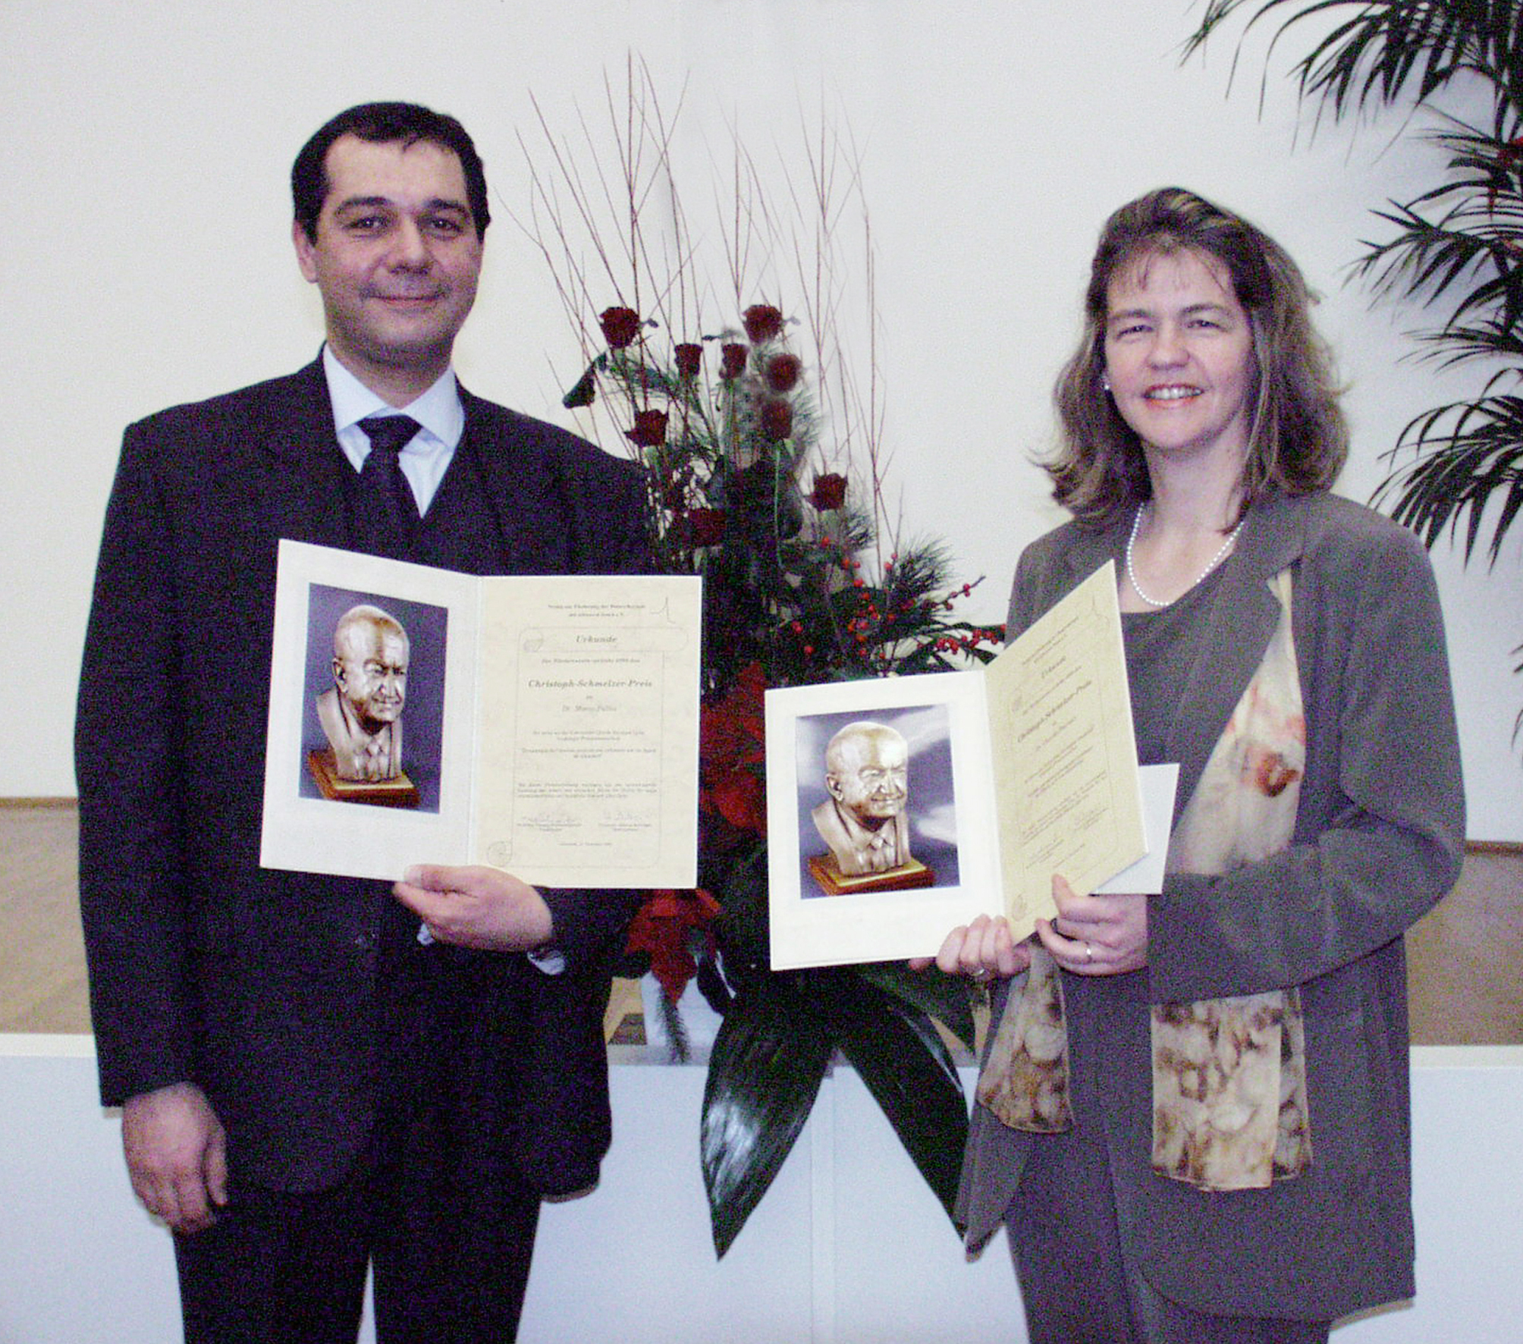

This award is endowed by the Association for the Advancement of Heavy-Ion Therapy, Darmstadt. G. Kraft. T. Haberer, GSI, Planckstr. 1, Darmstadt; J.Debus, DFKZ, Im Neuenheimer Feld 280, Heidelberg, Germany.

News from the Proton Medical Research Center, Tsukuba, Japan:
This is a progress report of ongoing project of Proton Medical Research Center, University of Tsukuba, building a new proton therapy facility. We completed the building construction and installation of equipment until the end of March 2000. We have moved to the new facility. After the tuning of equipment, we have started beam test from September 2000. Activities at the old facility in KEK have ended in July 2000.
At present, we are in the first stage of beam tuning. Note that the following data are preliminary. The current of 7MeV LINAC (3MeV RFQ + 7MeV DTL) is about 10 mA. At present, we have four effective beam turns captured by RF. The beam was accelerated to 250 MeV and extracted by the RF knockout method. The electric charge of the extracted beam was measured by a Faraday cup and found to be about 6 nC which corresponds to average current of 2 nA (repetition of synchrotron is 3 sec.). This value is about 20% of the design maximum of 9.6 nA. We will make an effort to increase the beam intensity further. The beam energy was measured by a multi-layer Faraday cup (MLC) located at the end of the straight section of the beam line. It is found that the MLC system works good. It was verified that the beam could be successfully transported to the end of two gantry beam lines and of two fixed beam ports. The beam spot size at the end of the gantry beam line was about 5 mm FWHM. The beam position seems to be very stable, which is one of our main design goal for getting stable uniform beam using the double scattering system. The vertical beam emittance was measured to be about 4-5π mm.mrad. We measured the Bragg curves of the 250 MeV beam around the isocenter using the water phantom detector with a thimble chamber. The distal falloff was about 5 mm.
The mechanical isocenter precision of the rotating gantries was measured. It was found that the isocenter resides within a cube of 1 mm perimeter for all rotation angle. We also measured the position accuracy of patient couch. The overall position accuracy was found to be within ±0.5 mm.
The beam tuning is scheduled to last until March. After that, we will make dosimetry measurements and verification of proton treatment planning and perform some biological experiments for verification of biological effectiveness of the beam. We hope to start the patient treatment as soon as the preparation will complete. Yoshihisa Takada, Proton Medical Research Center, University of Tsukuba, 1-1-1 Tennoudai, Tsukuba, Ibaraki 305-857, Japan.

News from TERA, Italy: The First Module Of The Proton-Linac ‘Libo’ Has Been Tested At Full Power
In 1993 the TERA Foundation (Novara, Italy) initiated the design of a novel proton linear accelerator based on the same high frequency (3 GHz) which is used by the many thousands electron accelerators running in hospitals all over the world. The working group was chaired by Mario Weiss, a former member of CERN and now with TERA. Chapter 9 of the Green Book [1] is devoted to such a design. The first part of this linac was further developed by Luigi Picardi et al. for the TOP project of the Istituto Superiore di Sanità, which aims at a beam of 70 MeV and is being built in Rome [2].
The second part of the linac is based on the Los Alamos structure called Side Coupled Linac (SCL) used only at much lower frequencies and higher injection energies. This 60-200 MeV linac has a wide range of applications, since it was conceived from the beginning as a linac booster (LIBO): it can be mounted downstream of a 50-70 MeV cyclotron - many of which exist in hospitals, isotope production centres and nuclear physics laboratories – so to boost the energy of the proton beam up to 200 MeV, the energy needed for therapy of deep seated tumours.
Never have protons been accelerated with a linac running at such a high frequency, while the about 5'000 electron linacs used for radiotherapy in the world run at 3 GHz. The choice is dictated by the fact that the higher the frequency, the larger the allowed accelerating gradient and, consequently, the shorter the linac. But in a copper structure, with an external diameter of 10 cm only, the beam hole has to be kept small (< 10 mm) and one could worry about the transmission of the cyclotron beam. Moreover, a cyclotron produces a DC beam while a linac is pulsed with a low duty cycle in an asynchronous mode with respect to the very low cyclotron accelerating frequency. Fortunately these two facts do not forbid the use of a high frequency linac downstream of a cyclotron because the beam intensity needed for protontherapy is small - about 10¹⁰ particles per second, i.e. two nanoamperes - and such low current can pass through the 8 mm hole of a linac structure if the protons are adequately focussed along the linac by permanent quadrupoles placed at less than 50 cm distance.
Since the cyclotron current is usually much larger, the source can be pulsed at the linac repetition rate (400 Hz) and, even if the capture rate of the linac is very small, the output average current is what is needed for deep therapy. From the beginning of the project, beam optics computations have indeed shown that a 3 GHz LIBO can have an overall efficiency of 2 x 10⁻⁴, so that a 50 µA cyclotron average current gives an output current of 10 nA, more than what is needed for therapy.
LIBO is about 15 m long and has been laid out as a modular structure, composed of nine modules, each of which, fed by its own RF power supply, can be considered as an RF unit. All the modules are identical, except for the slight progressive change in length, in agreement with the increased velocity of protons, accelerated from 62 to 200 MeV (the relativistic beta varies from 0.35 to 0.57). Each module consists of 4 ‘tanks’ whose lengths vary between 25 cm, in the first module, and 40 cm in the ninth module. The geometry of all the cells remains essentially the same. The accelerating cells increase slightly in length from tank to tank, while the coupling cells increase only from module to module. A permanent magnetic quadrupole is placed between two successive tanks to focus the proton beam; all 36 quadrupoles of LIBO are identical.
The power requirement is modest. To produce an average accelerating gradient in each tank of 15 MV/m (corresponding to an overall average gradient of about 10 MV/m) each one of the 36 tanks requires a peak power of the order of 1 MW. Given the low duty cycle (0.2%) the average RF power is about 70 kW.
Detailed dynamic calculations show that, by switching off the last klystrons one by one and/or reducing their power, it is possible to obtain a beam of variable energy in the range 130 – 200 MeV. This makes LIBO more similar to a synchrotron than to a cyclotron, as far as the energy is concerned. On the other hand, the beam structure is very suitable for the active scanning techniques now in use in hadrontherapy, since the 2.5 ms that separate two consecutive proton pulses are exactly what is needed to move the beam in the voxel scanning mode used at PSI.
In 1998 an international collaboration was set up among four groups of scientists from TERA (M. Weiss, Project Leader, et al.), CERN (E. Rosso et al.), the INFN Sections of Milan (C. De Martinis et al.) and of Naples (V. Vaccaro et al.). The collaboration aims at constructing and testing the first module of a LIBO that accelerates protons from 62 MeV to 74 MeV.

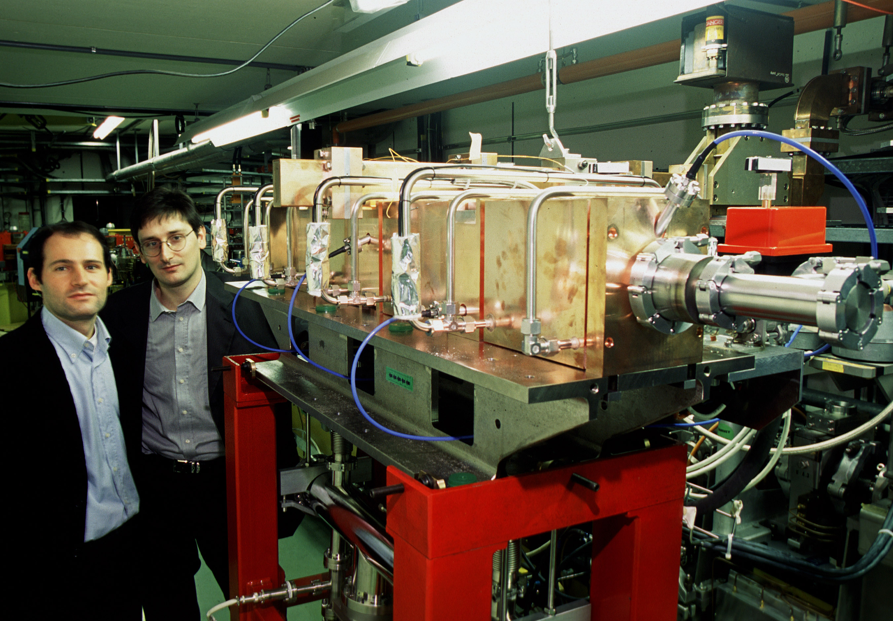
Figure 1. In November the LIBO module was installed in the tunnel of LIL, the CERN high-energy 3 GHz electron-linac, in order to make use of the power produced by a spare klystron. The testing conditions were: nominal peak power = 4 MW, repetition rate = 100 Hz, pulse duration = 5 µs.

The construction of the accelerating copper structure was done in the CERN workshops and the focussing (four permanent 3 cm long quadrupoles) and precise support systems were provided by INFN. The four tanks in the module are connected via bridge couplers (three per module). The RF power input is located in the central bridge coupler, while the other two contain pumping ports. All the elements of the module were brazed together in about four subsequent brazing steps. More technical details may be found in a paper submitted to EPAC 2000 [3]. Fig. 1 shows the module installed in the tunnel of the CERN electron linac after November 2nd 2000, when LEP was definitively stopped.
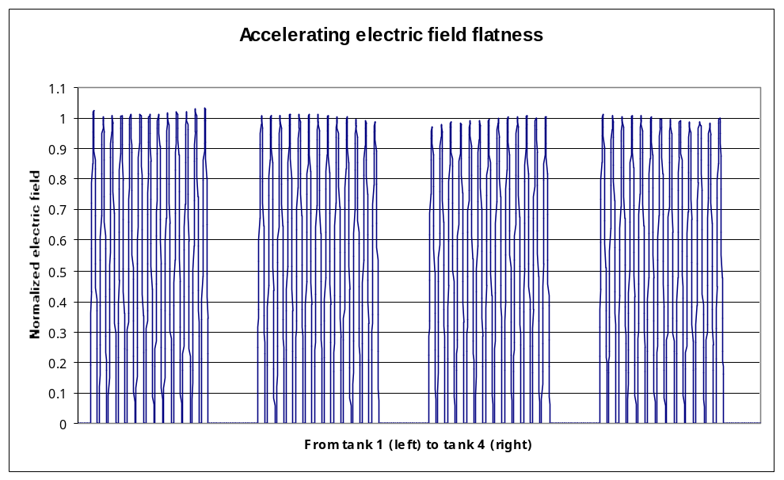Using an existing 3 GHz modulator and control system, full power RF measurements have been performed producing – after a short conditioning period - in each of the four tanks a gradient of about 30 MV/m, much larger than the project value of 15 MV/m. The distribution of the accelerating field measured at low power is shown in Fig. 2.
Figure 2. The accelerating field is plotted versus the position on the axis of the module. The 13 cells of each of the four tanks are clearly visible. In the 52 cells the accelerating fields are equal within a maximum spread of ± 2.8 %.

What next? In October 1999 the Scientific Committee of the INFN Laboratori Nazionali del Sud from Catania accepted the proposal to test this LIBO module with protons extracted at 62 MeV from the Catania superconducting cyclotron. The collaboration aims at installing the LIBO module and the diagnostic equipment on the beam line in spring 2001, so to complete the acceleration test by fall of 2001.
The LIBO Collaboration has reached an agreement with Scanditronix (Uppsala), which recently teamed with IBA (Louvain-la-Neuve) to market protontherapy accelerators. Scanditronix has developed a novel solid-state compact 3 GHz modulator and is interested in the potentialities of LIBO. One of these modulators will be lent without charge to the LIBO Collaboration and used to perform the acceleration tests in Catania.
The tests of Module 1 will open the way to a true technological transfer of the accumulated know-how to a consortium of companies, which will propose it to the medical market. This is a concrete possibility, because one can build, with an existing 50-70 MeV cyclotron and a LIBO, a very advanced facility for deep protontherapy. During the year 2001 the collaboration will look for companies interested in investing money, build together the first full LIBO and share the possible future advantages of such an industrial enterprise. It is foreseen to involve Scanditronix for the RF system and an Italian mechanical industry for the accelerating structure and the general mechanics. A third company – not yet defined - should take the responsibility of the diagnostic instrumentation, of the control system and of the integration of LIBO with all the other components necessary in a hospital environment.
REFERENCES: [1] The RITA Network and the Design of Compact Accelerators, U. Amaldi, M. Grandolfo and L. Picardi Eds., INFN, Frascati, 1996. The "Green Book". [2] Progetto del TOP Linac, L.Picardi et al, ENEA, Roma, ISSN/1120-5571, July 1997. [3] P. Berra et al., Study, Construction and Test of a 3 GHz Proton Linac-Booster (LIBO) for cancer therapy, Proc. EPAC 2000, Vienna, 26-30 june 2000, CERN, Geneva, 2000, 2495. P. Berra, E. Rosso, B. Szeless, M. Vretenar, CERN, Geneva, Switzerland; C. Cicardi*, D. Giove, C. De Martinis*, University (*) and INFN – Milano; D. Davino*, M.R. Masullo, V.G. Vaccaro*, University(*) and INFN – Naples; U. Amaldi, K. Crandall, R. Zennaro, M. Weiss, TERA Foundation, Novara.

IN MEMORIAM
Cornelius A. Tobias (1918-2000)

On May 2nd 2000, Professor Cornelius A. Tobias died peacefully in his home in Eugene, Oregon at the age of 81. “Toby” was born on May 28, 1918 in Budapest, Hungary. In 1939 as a young Physics student at the Hungarian University for Electrical and Technical Sciences in Budapest, he was awarded a one-year Hungarian-American fellowship to work in E. O. Lawrence’s laboratory in Berkeley, California. When he first met Ernest, Toby expressed an interest in nuclear physics and its possible applications to medicine. Ernest enthusiastically replied that he and his brother John, who was a physician, had similar interests. The synergistic efforts of the Lawrence brothers and Toby initiated a remarkable era for radiation research. Toby’s leadership in this field during the 1970’s and 1980’s earned him the recognition by his colleagues as “The Father of Heavy Ion Therapy”.
Toby received his M.A. (1940) in Physics and Ph.D. (1942) in Nuclear Physics from the University of California with E. O. Lawrence, E. Segre and L. Alvarez as his academic advisors. Upon completing his Ph.D., Dr. Tobias was employed by the University of California as a physicist and a founding member of the Donner Laboratory. After a distinguished career, Professor Tobias retired in 1987 as a Faculty Senior Scientist after 45 years of service at the Lawrence Berkeley National Laboratory. He attained professor emeritus status at the University of California in 1988.
Tobias is best known for his leadership during the last forty years of his professional career in the field of basic radiobiology of high-LET radiations, and the applications of high-LET radiation in the form of accelerated heavy particles to cancer research and therapy. His interest in heavy ions began with his dissertation work accelerating carbon nuclei in a cyclotron to an energy of 96 MeV to study nuclear reactions. In 1948, his group proposed the possible use of uranium in neutron capture (fission) therapy and his group was the first to characterize the depth ionization behavior of high-energy deuterons produced in the 184" cyclotron. They developed most of the methodology for measuring ionization, dose and fluence of charged particle beams, and also measured the stopping power of various elements.
The group was the first to demonstrate that most of the biological effects of a particle beam could be localized in deep tumors. Tobias and D. Van Dyke led a team, which showed that high-energy deuterons can produce precisely localized lesions in the pituitary gland and in the brain of rodents and could produce hypophysectomized states in rodents and in primates. This work led in 1955 to the initial use of 340 MeV proton beams and 900 MeV helium beams in human therapy. The initial studies included the use of these beams for pituitary radiation in metastatic mammary cancer, other endocrine cancers and diabetes mellitus with associated vascular disease, acromegaly and Cushing’s disease. A study over more than 20 years on several hundred patients has proved the efficacy of helium ions for such treatments. Tobias spent a sabbatical year (1956) at Uppsala and Stockholm, at the invitation of The Svedberg, helping Swedish-investigators begin biomedical applications of protons. In 1960, Tobias attended a radiobiology conference in Moscow and participated in intense discussions at the laboratory in Dubna, which contributed to the establishment of the three Soviet proton research medical programs.
Soon after heavy primary cosmic rays were discovered in high altitude balloon flights, Tobias wrote one of the earliest articles on the potential hazards of these rays in space flight. He predicted that individual heavy ions passing through the retina might produce visual effects and that a very heavy particle could perhaps kill or modify a row of cells in its path. About 20 years later, during the first lunar flight, American astronauts did indeed observe visual stars and streaks. In 1972, for his contributions in the field of space sciences, he received the Annual Award of the American Nuclear Society, Aerospace Division.
When low energy accelerated heavy ions became available at the Berkeley high energy linear accelerator (HILAC), Tobias and his coworkers developed the technology required to conduct biophysical experiments with particle beams. Tobias and P. Todd proposed in 1967 that accelerated heavy ions might be useful in cancer therapy. From 1971, such beams were available at the Bevatron, which was later joined with HILAC to become the Bevalac. From 1975, the Tobias group was an active center of basic radiobiological research with high-energy heavy ions and in their potential application in cancer therapy. This culminated in a clinical program comparing the therapeutic effectiveness of heavy-ion versus helium-ion beams, which was led by J. Castro, University of California at San Francisco.
Several novel ideas were developed in Tobias’ group using heavy accelerated ions. In 1971 Tobias and A. Chatterjee produced for the first time “autoradioactive” beam particles, particles that become radioactive during their passage through matter. Tobias also conceived some methods for using heavy accelerated ions for radiography with the advantage of very high density resolution at a low exposure dose. He also devised a unique idea to solve the problem of reduced effectiveness of ion beams in therapy due to beam fragmentation effects. He suggested that the primary beam be swept in two directions with magnetic fields in the x-plane and the y-plane in order to spread the primary particles without the need for fragmentation processes. The merits of this approach were confirmed experimentally by W. Chu and others and the wobbler beam delivery system became a practical mode of beam delivery in the Phase I/II neon cancer therapy trials in Berkeley. He also suggested that particle beams could be scanned to “paint the volume of the tumor in three dimensions”. The feasibility and safety of this concept was implemented in Berkeley, and is currently used in clinical trials in Germany.
The personal side of Professor Tobias was filled with family, hiking and music. The recent Tobias book, “People and Particle”, published with his wife Ida in 1997, describes a highly personal odyssey - a delightful recounting of personal anecdotes intertwined with groundbreaking scientific work and insights, in the context of the historical development of the Lawrence Berkeley and Donner Laboratories.
Tobias is certainly missed by his family and by the large number of younger colleagues with whom he shared his humor, endearing modest demeanor, high integrity and love of life. Tobias’ legacy however is the large number of individuals worldwide to whom he imparted scientific curiosity for peaceful applications of radiation sciences.
Taken from an obituary written by Eleanor Blakely for publication in “Radiation Research”.

TREATMENT PLANNING SYSTEMS FOR PROTON THERAPY
January 2001
The following Table was presented in October 1999 by Skip Rosenthal, MGH at the Workshop on Treatment Planning Systems, PTCOG XXXI. Information was provided by: S. Rosenthal, A. Mazal, M. Collier, T. Lomax, S. Nill, and D. Miller. This Table is a new feature of Particles, and will be updated each issue. Please send corrections/additions to Janet Sisterson.

Year | Created By | System Name | Status
1979-93 | LBL | LBL system | Not Available
1980 | MGH | Rx | Distributor MGH
1980 | MGH | EYEPLAN | Distributor MGH – EYES only
1990-96 | MGH/Seimens | V-Treat(AXIOM) | Not Available
198?,1991 | PSI | PSI system/Pion | Distributor PSI
1995 | DKFZ/Royal Marsden | Voxelplan/Proxelplan | Adapted by GSI, NAC, DKFZ
1996 | Radionics/MGH/HCL | P-Knife | Not Available
1997 | LLUMC/PerMedics | OptiRad 3D | FDA approved; commercial
1998 | Tsukuba | Hitachi system | In-house system
1998 | DKFZ | OCTOPUS | Under development – EYES only
1994 | Orsay/Curie | ISIS | Distribution ?
1998 | CMS/MGH | FOCUS | Commercial Release 1999
1998 | DKFZ | KonRad Plus Protons | Research Only
199? | Uppsala/KVI | Helax (+ protons) | Distribution ?
 | RenderPlan |  | ?
 | Adac |  | ?
 | Michigan |  | ?
 | Varian |  | ?

Proposed NEW FACILITIES for PROTON & ION BEAM THERAPY - January 2001

INSTITUTION | PLACE | TYPE | 1ST RX? | COMMENTS
INFN-LNS, Catania | Italy | p | 2001 | 70 MeV; 1 room, fixed horiz. beam
NPTC (Harvard) | MA USA | p | 2001 | at MGH; 230 MeV cyclotron; 2 gantries + 2 horiz
Hyogo | Japan | p, ion | 2001 | 2 gantries; 2 horiz; 1 vert; 1 45 deg; nearing completion
NAC, Faure | South Africa | p | 2001 | new treatment room with beam line 30º off vertical.
Tsukuba | Japan | p | 2001 | 270 MeV;2 gantries;2 fixed; construction complete
Wakasa Bay | Japan |  | 2002 | multipurpose accelerator; building completed mid 1998
Bratislava | Slovakia | p, ion | 2003 | 72 MeV cyclotron; p; ions; +BNCT, isot prod.
IMP, Lanzhou | PR China | C-Ar ion | 2003 | C-ion from 100MeV/u at HIRFL expand to 900 MeV/u at CSR;clin. treat;biol. research;no gantry;shifted patients
Shizuoka Cancer Center | Japan |  | 2003 | synchrotron 230? MeV; 2 gantries; 1 horiz; funded.
Rinecker, Munich | Germany | p | 2003 | 4 gantries, 1 fixed beam, 230 MeV, scanning beams.
CGMH, Northern Taiwan | Taiwan | p | 2001? | 250MeV synchrotron/230MeV cyclotron;3 gantry,1 fixed
Erlangen | Germany | p | 2002? | 4 treatment rooms, some with gantries.
CNAO, Milan & Pavia | Italy | p, ion | 2004? | synchrotron; 2 gantry;1 fixed beam rooms;1 exp. room
Heidelberg | Germany | p, ion | 2005?
AUSTRON | Austria | p, ion | ? | 2p gantry;1 ion gantry;1 fixed p;1 fixed ion;1 exp room
Beijing | China | p | ? | 250 MeV synchrotron.
Central Italy | Italy | p | ? | cyclotron; 1 gantry; 1 fixed
Clatterbridge | England | p | ? | upgrade using booster linear accelerator to 200 MeV?
TOP project ISS Rome | Italy | p | ? | 70 MeV linac; expand to 200 MeV?
3 projects in Moscow | Russia | p | ? | including 320 MeV; compact, probably no gantry
Krakow | Poland | p | ? | 60 MeV proton beam.
Proton Development N.A. Inc. | IL USA | p | ? | 300 MeV protons; therapy & lithography
PTCA, IBA | USA | p | ? | Several systems throughout the USA
WORLD WIDE CHARGED PARTICLE PATIENT TOTALS
January 2001

WHO | WHERE | WHAT | DATE | DATE | RECENT | DATE
 |  |  | FIRST | LAST | PATIENT | OF
 |  |  | RX | RX | TOTAL | TOTAL
Berkeley 184 | CA. USA | p | 1954 | — 1957 | 30
Berkeley | CA. USA | He | 1957 | — 1992 | 2054 | June-91
Uppsala | Sweden | p | 1957 | — 1976 | 73
Harvard | MA. USA | p | 1961 |  | 8747 | Jan-01
Dubna | Russia | p | 1967 | — 1974 | 84
Moscow | Russia | p | 1969 |  | 3268 | June-00
Los Alamos | NM. USA | π ⁻ | 1974 | — 1982 | 230
St. Petersburg | Russia | p | 1975 |  | 1029 | Jun-98
Berkeley | CA. USA | heavy ion | 1975 | — 1992 | 433 | June-91
Chiba | Japan | p | 1979 |  | 133 | Apr-00
TRIUMF | Canada | π ⁻ | 1979 | — 1994 | 367 | Dec-93
PSI (SIN) | Switzerland | π ⁻ | 1980 | — 1993 | 503
PMRC, Tsukuba | Japan | p | 1983 |  | 629 | Jul-99
PSI (72 MeV) | Switzerland | p | 1984 |  | 3253 | Dec-00
Dubna | Russia | p | 1987 |  | 79 | Dec-00
Uppsala | Sweden | p | 1989 |  | 236 | June-00
Clatterbridge | England | p | 1989 |  | 999 | June-00
Loma Linda | CA. USA | p | 1990 |  | 5638 | Dec-00
Louvain-la-Neuve | Belgium | p | 1991 | – 1993 | 21
Nice | France | p | 1991 |  | 1590 | June-00
Orsay | France | p | 1991 |  | 1894 | Jan-01
N.A.C. | South Africa | p | 1993 |  | 380 | Nov-00
MPRI | IN USA | p | 1993 |  | 34 | Dec-99
UCSF - CNL | CA USA | p | 1994 |  | 284 | June-00
HIMAC, Chiba | Japan | heavy ion | 1994 |  | 745 | Dec-99
TRIUMF | Canada | p | 1995 |  | 57 | June-00
PSI (200 MeV) | Switzerland | p | 1996 |  | 41 | Dec-99
G.S.I Darmstadt | Germany | heavy ion | 1997 |  | 72 | June-00
Berlin | Germany | p | 1998 |  | 166 | Dec-00
NCC, Kashiwa | Japan | p | 1998 |  | 35 | June-00
 |  |  |  |  | 1100 | pions
 |  |  |  |  | 3304 | ions
 |  |  |  |  | 28700 | protons
 |  |  |  | TOTAL | 33104 | all particles

The Proposed Facilities List is on the previous page.

