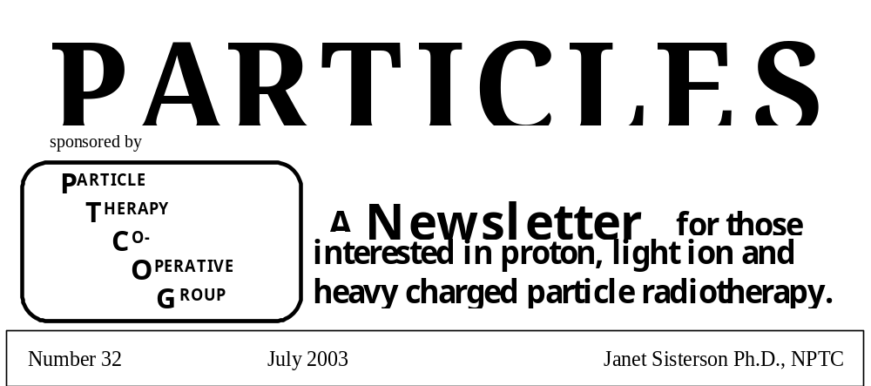

Costs: At PTCOG XIX, the Steering Committee decided that part of the registration fee for PTCOG meetings would be used to help produce both Particles and the abstracts of the PTCOG meetings. Only part of the costs is covered in this way, so more financial help is needed from the community. PTCOG is always happy to receive financial gifts; all such gifts are deductible as charitable contributions for federal income tax purposes. The appropriate method is to send a check made out to the “Massachusetts General Hospital” and sent to Janet Sisterson at the address given below.

Facility and Patient Statistics: I continue to collect information about all operating or proposed facilities. Please send me your information. My latest soon- to-be- published summary of the worldwide detailed patient statistics through 2001 is:
“Status of Ion beam therapy in 2002.” Author: J. M. Sisterson. It will be published in the Proceedings of the – Seventeenth Int’l Conf., Application of Accelerators in Research and Industry. Once it is published, copies will be available on request.

Particles Newsletter and Abstracts from PTCOG meetings. Particles and the Abstracts from the last PTCOG meeting will continue to be issued on a CD. Computerized Medical Systems (CMS) in St Louis has kindly offered to cut the CDs. I thank them for their support of Particles.

NEW!! Please join!!!! PTCOG Mail server: Niek Schreuder and colleagues at the Midwest Proton Radiotherapy Institute in Bloomington, Indiana have initiated this new service. Here is how to join:
You can email Niek Schreuder at aschreud@indiana.edu and ask to be added to the mail server referred to as the PTCOG_List. This they can do without having to join Yahoo. Better, however, is to join yahoo by getting a yahoo account and login - free of charge - and then join the PTCOG_list group – see instructions below. This will allow them to see previous mailcommunications and other advantages.
Here is a sample set of instructions.

"If you would like to learn more about the PTCOG_List group or join the group, please visit http://groups.yahoo.com/group/PTCOG_List. To send a message to all the members (after you have joined) simply send email to PTCOG_List@yahoogroups.com". Only members can post messages to the group. A member is defined as someone who’s email address is in the yahoo PTCOG_List. To unsubscribe from this group, send an email to: PTCOG_List-unsubscribe@yahoogroups.com.

Particles on the Internet The web page for PTCOG and the Particles Newsletter is found at: http://ptcog.mgh.harvard.edu.

Other proton therapy links:
NPTC, MGH, Boston: http://cancer.mgh.harvard.edu/cancer_radonc_nptc_home.htm
LLUMC, California: http://www.llu.edu/proton
U of California, Davis: http://crocker.ucdavis.edu/cnl/research/eyet.htm
Midwest Proton Radiotherapy Institute: http://www.mpri.org
National Association for Proton Therapy: http://www.proton-therapy.org
TRIUMF, Canada; protons: http://www.triumf.ca/welcome/proton_thrpy.html
TRIUMF, Canada; pions: http://www.triumf.ca/welcome/pion_trtmt.html
CPO, Orsay, France: http://www.protontherapie-orsay.fr
PSI, Switzerland: http://radmed.web.psi.ch
TERA foundation, Italy: http://www.tera.it
Catania, Italy: http://www.lns.infn.it
GSI homepage: http://www.gsi.de
HMI Berlin: http://www.hmi.de
The Svedborg Laboratory, Sweden: http://www.tsl.uu.se
Clatterbridge Centre for Oncology: http://synaptic.mvc/mcc.ac.uk/Proton/clatterbridge.htm
Clatterbridge collaboration with the CASIM project: http://www.casim.ac.uk
Rinecker Proton Therapy Center, Munich, Germany: http://www.rptc.de
ITEP, Moscow, Russia: http://www.protontherapy.itep.ru
Tsukuba, Japan - PMRC: http://www.pmrc.tsukuba.ac.jp/index.html
HIBMC, Hyogo, Japan: http://www.hibmc.shingu.hyogo.jp/english/aisatu-e_top.htm
HIMAC, Chiba, Japan: http://www.nirs.go.jp/ENG/particl.htm (ENG case sensitive)
IThemba LABS, South Africa: http://medrad.nac.ac.za/index.htm

ARTICLES FOR PARTICLES 33

The deadline for articles for the Particles 33 is November 30 2003 and should NOT exceed two pages in length. Please send all articles to:

Janet Sisterson Ph.D. Telephone: (617) 724-1942
Northeast Proton Therapy Center Fax: (617) 724-9532
Massachusetts General Hospital E-mail: jsisterson@partners.org
30 Fruit Street, Boston MA 02114

PTCOG BUSINESS and FUTURE PTCOG MEETINGS

The Chairperson, Secretary and Steering Committee members are listed below. The Chairperson and Steering Committee were appointed in June 2001 for 3 years. Their appointments run through June 2004. We hope to have arranged for the election of new officers by the time we meet in Paris in June 2004.

Chair: Gudrun Goitein | Secretary: Janet Sisterson
Paul Scherrer Institute  Division of Radiation Medicine  Villigen PSI CH-5232  Switzerland | Northeast Proton Therapy Center  Massachusetts General Hospital  30 Fruit Street  Boston MA 02114

MEMBERS OF THE STEERING COMMITTEE
Canada | TRIUMF, BC | E. Blackmore
France | Orsay | G. Noel
Germany | GSI/Heidelberg | J. Debus
 | HMI, Berlin | H. Kluge
Italy | Catania, Sicily | L. Raffaele
Japan | HIMAC, Chiba | H. Tsujii
 | NCC, Kashiwa | T. Ogino
 | PMRC, Tsukuba | Y. Akine
 | HIBMC, Hyogo | Y. Hishikawa
 | Wakasa Bay, Japan | S. Fukuda
Russia | ITEP, Moscow | V. Khoroshkov
 | JINR, Dubna | G. Mytsin
South Africa | IThemba LABS | D. Jones
Sweden | Uppsala | E. Blomquist
Switzerland | PSI | G. Goitein
UK | Clatterbridge | A. Kacperek
USA | NPTC-MGH/HCL, MA | S. Rosenthal
 | LLUMC, CA | D. Miller
 | MPRI, IN | N. Schreuder
 | Berkeley, CA | W. Chu

The times and locations of the next PTCOG meetings are as follows:

PTCOG 39 | San Francisco, hosted by UCSF, Berkeley and Varian | October 27 – 29 2003
PTCOG 40 | Paris and CPO, Orsay, France | June 16 - 18 2004
PTCOG 41 | MPRI, Indiana, USA | Fall 2004
PTCOG 42 | Kashiwa, Japan hosted by NCC, and Shizuoka | Spring 2005
PTCOG 43 | Munich, Germany hosted by RPTC | Fall 2005
PTCOG 44 | PSI, Switzerland | Spring 2006
PTCOG 45 | M. D. Anderson, Houston, TX, USA | Fall 2006

Letter from the PTCOG President

Dear friends and colleagues,
PTCOG XXXVIII in Chester was an eye-opener, wasn’t it? Of course, almost the whole spectrum of our field was covered, ranging from physics over various clinical applications of proton beams to ocular treatments. I had to miss the first day, unfortunately, but I nevertheless could enjoy excellent presentations. The approach to embed the philosophy and performance of proton beam radiotherapy in general radio-oncology problems, needs and solutions was much more than just interesting. It was important and convincing. Overview talks given by clinicians who are not (yet) involved in proton therapy showed clearly where we should go: to clinical practice, well defined indications and medical programs which include surgery, medical oncology and proton radiotherapy (and x-ray therapy) right from the beginning, when medical concepts are made. Thank you to the guest speakers!
It was impressive to see and hear how engaged the whole Clatterbridge team is. They have a fine and fruitful co-operation with the ophthalmologist, and the in-house work on Eye-Plan has brought this program forward to more modern and more sophisticated use. Andrzej Kacperek and his team organized a meeting, which not only was professionally excellent, but also had a fine venue and very good social events. Thank you to all of the Team!
Now we are heading on to the next meeting, which will be held, as we decided at the Steering Committee, close in time to a major radiation oncology conference. This is a move towards getting us out of the “house for exotic birds” into the colorful world of cancer treatment. We won’t be able to connect all future PTCOG’s with other meetings since we also “use” our conference to give local projects importance and support. But we should put substantial effort into presenting our activities and treatment results outside PTCOG. That’s the way to be seen and heard - and to learn through contact with sometimes critical experts. I hope that ASTRO participants will be able and interested in joining PTCOG XXXIX in San Francisco, and that PTCOG members will be able to join ASTRO. We are looking forward to follow Bill Chu’s and his supporting team’s invitation. We’ll pack interesting facts, burning questions, fascinating results and various little problems in our knapsacks and fly over. Hopefully, that kind of luggage will get through the controls!
I send you warm regards from really sunny Switzerland. Have a nice summer!

Gudrun Goitein, July 2003

Minutes of the Steering Committee Meeting
held at
PTCOG 39
Chester, UK, May 2003

The meeting was chaired by Gudrun Goitein. Attendees included: Janet Sisterson, Niek Schreuder, Joerg Hauffe, Les Yonemoto, Loic Feuvret, Phil Pepmiller, Michael Jackson, Jim Metz, Marcel Marc, Dan Jones, Andrzej Kacperek, Erik Blomquist, Takashi Ogino.

Future Meetings
In addition to the PTCOG meetings listed in the table above, the following institutions would like to host a PTCOG meeting: Loma Linda; IBA-Zibo-Beijing; and Uppsala in 2008.
Participants are reminded that hotel reservations for the meeting next June in Paris will have to made VERY EARLY, probably by January 2004. See further preliminary information about this meeting below.

Suggested meeting format
1) Try with some frequency to coordinate meetings with major meetings, ASTRO and ESTRO in particular.
2) Encourage PTCOG members to present their results at major meetings, particularly clinical results.
3) It was suggested that perhaps we could organize Workshops at major meetings.
4) Meeting organizers are reminded that it is very advantageous to have the first talks at PTCOG – or the first talks in a particular session – be introductions to the topic of the session. In that way we can enhance the teaching aspect of PTCOG.

Education Possibilities
Gudrun stressed the educational aspects of PTCOG and encouraged institutions to advertise their training programs. For example, PSI has the following training opportunity, see the announcement below.

Future of PTCOG
- In the future, Steering Committee meetings will be planned for the day before PTCOG to allow more time for discussion.
- An agenda for each PTCOG Steering Committee meeting will be developed and circulated to members before the meeting
- In JUNE 2004, new Steering Committee and Chairperson must be elected.
- We should use this opportunity to modify the organization and format of PTCOG.
- It was suggested that PTCOG be set-up as a non-profit organization
- A committee will be established to write the constitution
- Steering committee meetings are open to all interested parties but voting on any issue is restricted to the committee members or their elected substitute.

All thoughts, ideas, suggestions are welcome from all members of the PTCOG community. If you are interested, please try and attend the Steering Committee meeting to be held at the San Francisco meeting in October. At this meeting we will have to decide how to conduct the election and perhaps begin to explore the changes that might be made to the PTCOG organization. Please send all suggestions to both Gudrun Goitein and Janet Sisterson.

Honorary Members
In 2001, at the suggestion of Michael Goitein the category “Honorary member of PTCOG” was created. This award would be bestowed by the Steering Committee on a member who satisfied the following criteria”

- Has played a significant role in the leadership, organization and promotion of charged particle therapy
- Has reached some maturity of years

In addition to the honour of the title, it was suggested that the registration fees for PTCOG meetings be waived for Honorary members to encourage their extended participation.
At the Clatterbridge PTCOG meeting, Michael Goitein was elected to Honorary Membership. The other Honorary members are: Herman Suit and Kiyomitsu Kawachi.

PTCOG 39
San Francisco, CA, USA
27 –29 October 2003
co-sponsored by
University of California, San Francisco and Lawrence Berkeley National Laboratory

The 39th meeting of the PTCOG will be held on October 27- 29 2003, at the Fairmont Hotel, atop Nob Hill, San Francisco, California. The meeting will be co-sponsored by UCSF and LBNL. This two and one-half day meeting represents an opportunity to discuss recent advances in particle radiation therapy in beautiful San Francisco. Topics will include an update on particle therapy for ocular melanomas as well as proton and carbon beam therapy, and new and existing particle facilities. Details for the venues, events, and registration will be announced soon and will be posted on the PTCOG web-site as they become available.
Bill Chu and Lynn Verhey,
Local Organizing Committee.

Contact person for PTCOG-39-SF is Alan Taniguchi (UCSF).
Telephone: 415 353 9880
Fax: 415 353 9883
Email: taniguchi@radonc17.UCSF.edu

PTCOG 40
Paris, France
June 16 – 18 2004

Preliminary details of this meeting can be found at the website http://www.protontherapie-orsay.fr/ptcogcpo. Essential information is summarized below.

Registration Fee: approximately 270 euros, if paid before March 15 2004, 330 euros after this date. This includes all sessions, lunch and coffee breaks, CPO barbeque and book of abstracts. The registration form can be found on the web site.
Conference secretary: Peggy Bera at ptcogcpo@ipno.in2p3.fr. Centre de Protontherapie d’Orsay, Phone: +33 1 69 29 87 29; fax +33 1 69 29 87 19. If you need an official invitation letter, contact the conference secretary.
Date and Place:
Tuesday June 15 18:00 Registration and welcome cocktail party in the Salon du Sénat
Wednesday June 16 Registration continues and the meeting begins in the Constant Burg Auditorium at the Curie Institute followed by the Conference dinner.
Thusday June 17 Special session to be held in the Pierre Lehmann Auditorium, Orsay and visit to CPO. Transportation from Paris to Orsay by RER is included in the registration fee. In the evening there will be a special show and barbeque in the gardens of the University.
Friday June 18 Meeting continues at the Curie Institute

Preliminary Program:
This will contain invited talks, selected oral contributions and poster sessions. All facility status reports will be accepted only for poster presentations. Proceedings of the conference will be published, which will contain the text of the invited talks.
Topics that will be covered include:
- Soft tissues and bone sarcomas
- Standard treatment modalities
- Combination radiotherapy, surgery and chemotherapy
- Interactive delineation of tumors
Contributions: A sample file in Word to be used for preparing the abstracts can be found on the conference web site. The abstract files must be submitted electronically before March 1 2004.
Lodging: Each participant is expected to make their own arrangements. Details can be found on the web site. Paris is a busy place, YOU MUST MAKE YOUR HOTEL RESERVATIONS EARLY and it is suggested that you should make your reservations by January 2004.
Deadlines:
- Abstracts of contributions January 15 2004
- Acceptance of contributions March 1 2004
- Final registration March 1 2004
- Final circular May 31 2004.

Please NOTE THE DATES OF THESE DEADLINES, for this meeting PTCOG members will have to plan well ahead.

Second announcement
9th HCPBM Workshop and ENLIGHT Meeting
LYON, France, 2-5 October 2003

Light ion therapy of cancer is now becoming a reality in Europe with the emergence of dedicated facilities and the networking and integration of all European projects. In this dynamical context, the series of workshops on Heavy Charged Particles in Biology and Medicine plays a fundamental role. Each year it gives an opportunity to clinicians, radiobiologists, medical physicists and accelerator physicists to have multidisciplinary exchanges on the more recent developments of this innovative therapy.
This year, the 9th HCPBM Workshop will take place in France, at Lyon, hosted by the ETOILE project group. A general meeting of ENLIGHT workgroups will follow.

Scientific Board | Organizing Committee
J.R. Alonso, Berkeley J-L. Habrand, Paris  U. Amaldi, Milano J. Hammer, Linz  T. Auberger, Innsbruck G. Kraft, Darmstadt  E.A. Blakely, Berkeley M. Krengli, Novara  A. Brahme, Stockholm P. Lukas, London  J. Debus, Heidelberg B.D. Michael, London  C. Détraz, Geneva J. Remillieux, Lyon  M. Durante, Napoli T. Tsujii, Chiba  J-P. Gérard, Nice A. Wambersie, Brussels | M. Bajard  J. Balosso  Y. Déclais  A. Demeyer  M. Dosanjh  A. Emsallem  J-C. Poizat  J. Remillieux (coordinator)  J. Rochat  D. Sappey-Marinier  B. Shariat

Scientific Programme: I/ HCPBM workshop (2-4 October)
- Radiobiology
- Treatment planning, dosimetry, imaging and PET
- Physics and space research
- Exotic ion therapies
- Accelerator technologies and gantries
- Clinical data and trials
- Epidemiology and socio-economic aspects.

Round tables will be organized on the following topics:
- How to record hadrontherapy medical files?
- New accelerator systems for hadrontherapy
- Socio-economic aspects of hadrontherapy in various countries.
Poster sessions will be devoted to:
- Radiobiology
- Physics, accelerators and gantries
- Treatment planning, dosimetry and PET
- Clinical data, epidemiology and treatment cost.

II/ ENLIGHT meeting (4-5 October)
Saturday afternoon: status reports on the four European projects of hadrontherapy centres, and information on the possible emergence of new projects, followed by a general discussion on coordination and collaborations.

Sunday morning: progress and programme reports of the ENLIGHT working groups:
- Epidemiology and patient selection (WP1)
- Design and conduct of clinical trials (WP2)
- Preparation, delivery and dosimetry of ion beams (WP3)
Preparation of ion beams (WP3.1)
Control systems and dosimetry of ion beams (WP3.2)
Treatment planning (WP3.3)
Accelerator technology (WP3.4)
- Radiation biology (WP4)
- In situ monitoring with PET (WP5)
- Health economic aspects (WP6)

Registration:The form must be returned as soon as possible by regular mail with the payment (please note that registration after 15th of August will be more expensive). The registration fees include on-site accommodation in Valpré, with single rooms, double rooms and a few triple rooms reserved for students. They also include lunches, coffee breaks, the conference dinner, the social events and the book of abstracts. Accompanying persons are welcome for on-site accommodation and participation to the social events and to the conference dinner. A social programme for a group of accompanying persons can be organized with the tourism office of Lyon.
Reception: Checking-in at the conference site Valpré is scheduled on Wednesday October 1st from 4 pm to 9 pm. A welcome buffet will be prepared. The access to the conference location Valpré (at Ecully, a city about 4 km from Lyon downtown) is given on the web site: http://www.valpre.com
Call for posters: All participants are invited to present their work by sending extended abstracts in view of poster presentations. All posters will be presented and discussed in special plenary sessions by a poster reporter. At the end of the meeting, awards will be attributed to the authors of the best posters.

GUIDELINES FOR SUBMISSION OF ABSTRACTS FOR THE POSTER SESSION
Authors are asked to submit their abstracts through the ESTRO website, which hosts an electronic abstract submission form. The maximum text length is 2500 characters. Abstracts sent by fax will not be accepted. Abstracts should be structured in such a way as to include (1) an introductory sentence indicating the purpose of the study and the names of co-operative study groups, if applicable; (2) a brief description of pertinent experimental procedures; (3) a summary of the new, unpublished data; and (4) a conclusion. Abstract titles should be brief and reflect the content of the abstract. The presenting author's name must be underlined. Omit degree, titles, address and zip code. The abstract should contain no illustrations but one table may be included. Abstracts must be written in English.

PLEASE SUBMIT YOUR ABSTRACT BEFORE 10 JULY 2003 ELECTRONICALLY THROUGH THE ESTRO WEB SITE: http://www.estro.be/FORMS/abstract/lyon_start.html

Proceedings: Abstracts of the selected poster presentations and of the invited papers will be published in a special issue, a supplement of Radiotherapy and Oncology (the Green Journal) after a reviewing procedure. It will be distributed free of charge to all participants at the beginning of the workshop and distributed also to all ESTRO members. This ensures a wide dissemination of information to libraries and electronic databases and allows the citation to be used in personal bibliographies. We intend also to publish a second issue in the same journal, which will contain papers corresponding to a few invited lectures chosen by the Scientific Board of the Lyon Workshop during the meeting.
Web site: Please visit the web site of the Workshop http://9hcpbm.univ-lyon1.fr. You are encouraged to print and post the workshop poster (included in the web site) in your laboratory and to circulate this announcement to your colleagues.

Joint ICRU/IAEA Committee
on
PRESCRIBING, RECORDING AND REPORTING PROTON BEAM THERAPY

The above Committee has been formed by the International Commission on Radiation Units and Measurements (ICRU) and the International Atomic Energy Agency (IAEA) to compile a report on proton beam therapy with the aim of standardizing techniques and procedures and to bring the clinical descriptions of proton treatments into line with those of other modalities. ICRU Reports 50 and 62 described the prescribing, recording and reporting of photon beam therapy. Similar ICRU reports are presently being prepared on electron beam therapy and IMRT. ICRU Report 59 on proton dosimetry will be updated. A comprehensive report is envisaged and will cover the technical, physical, biological and clinical aspects of proton therapy. Heavy ion therapy will not be included.
The Committee consists of both ICRU and IAEA appointees and sponsors. The Co-Chairs are Dan Jones of ICRU and iThemba LABS and Herman Suit of Massachusetts General Hospital. Financial support from Ion Beam Applications s.a. and Siemens Medical Solutions is gratefully acknowledged.

The members of the Committee are given below.
ICRU nominees
Co-Chairpersons:
D T L Jones (ICRU/ iThemba LABS, Somerset West, South Africa)
H D Suit (Massachusetts General Hospital, Boston, USA)
G Goitein (Paul Scherrer Institute, Villigen, Switzerland)
M Goitein (Private, Switzerland)
R L Maughan (Univ. Pennsylvania, Philadelphia, USA)

IAEA nominees
H Tatsuzaki (National Institute of Radiological Sciences, Chiba, Japan)
H Tsujii (National Institute of Radiological Sciences, Chiba, Japan)
S M Vatnitsky (Dosimetry and Medical Radiation Physics Section, IAEA)

ICRU sponsors
P M DeLuca Jr (Univ. Wisconsin, Madison WI, USA)
R A Gahbauer (Ohio State Univ., Columbus OH, USA)
A Wambersie (Univ. Catholique de Louvain, Brussels, Belgium)
G F Whitmore (Ontario Cancer Institute, Toronto, Canada)

IAEA sponsors
J H Hendry (Applied Radiobiology and Radiotherapy Section, IAEA)
C V Levin (Applied Radiobiology and Radiotherapy Section, IAEA)
K R Shortt (Dosimetry and Medical Radiation Physics Section, IAEA)

The first meeting of the Committee was held at IAEA headquarters and at the Algemeine Krankenhaus, Vienna from 29-31 May 2003. T Kanai attended the meeting in place of H Tsujii, who was unable to be present. The following observers also attended:

D Georg (Algemeine Krankenhaus, Vienna, Austria)
R Pötter (Algemeine Krankenhaus, Vienna, Austria)
D Prieels (Ion Beam Applications s a, Louvain-la-Neuve, Belgium)
C Höppner (Siemens Medical Solutions, Erlangen, Germany)

The Committee drew up draft contents (below) of the report. Comments are invited from the proton therapy community on the proposed contents as well as suggestions as to what should be included in the report. Some suggestions were received at a meeting held during PTCOG XXXVIII in Chester in May and these will be included in the final report. Please submit any comments or suggestions to Dan Jones (jones@tlabs.ac.za) or Herman Suit (hsuit@partners.org) before 31 August 2003.
The next meeting of the Committee is planned to take place at PSI, Villigen, Switzerland from 17-19 January 2004. It is hoped that a preliminary draft of the Report will be available by then.

PROPOSED CONTENTS OF REPORT
PREFACE
ACKNOWLEDGEMENTS
CONTENTS
EXECUTIVE SUMMARY
- To be written after completion of report
1. INTRODUCTION
- Scope and goals of report
- Relation to existing reports
(especially ICRU59)
- Rationale for proton therapy
- History of proton therapy
- Present status
(relative costs to be mentioned briefly)
- Future prospects
- Outline of report
2. GEOMETRIC AND DOSIMETRIC TERMS
- Volumes
(GTV, CTV, IM, SM, PTV, OARn, PRV)
- Dose descriptors
(including Absorbed Dose in Gy [Weighting Factor])
- Dose reporting levels
(2 for eyes, 3 for everything else ?)
3. PROTON BEAM DELIVERY AND PROPERTIES
(Update and expand ICRU59)
- Accelerators
- Beam modification
(including out-of-beam effects)
- Passive scattering
- Wobbling and scanning
- Distal edge tracking
- Physical parameters
(shape of beam)
- Beam quality
- Spectra
- Microdosimetry
- LET
- Special techniques
- Eye treatments
- SRS
4. DOSIMETRY
- Proton interactions
- Dose descriptors
- Absolute dosimetry
- Traceability of calibrations
- Relative dosimetry
- Beam monitoring
- Real time imaging of irradiated volume
5. RADIOBIOLOGY
- Evidence for radiation carcinogenesis
Human data
(Atomic bomb, irradiated patients, occupational exposure, accidents)
Animal data
(primates, rodents)
- RBE (in/out of beam path)
- Uncertainties and their impact
- Additional data requirements
- Cell kill/carcinogenesis/non-cancer injuries
- Dose-volume effects
- Carcinogenesis
- Other categories
6. TREATMENT PLANNING
- Simulate
- Scattered beams
- Wobbled/scanned beams
- Distal edge tracked beams
- Calculation techniques
- Broad beams
- Pencils→broad beams
- Pencils→scanned pencils
- Monte Carlo
- Mixed modality treatments
- Compensation
- Devices
- Scanning beam specifications
- Patient/Volumes Of Interest representation
- CT/MRI/PET
- Image fusion
- Other images
- Drawings
- Specification of error bands
- Display techniques
- Optimized physical dose distributions
- Optimized biological dose distributions
- (based on biological models)
- Pareto plots
- …………
- Dose summaries
- DVHs
- Hot and cold regions
- Plan evaluation/comparison
- Output documents
- Scanning file
- ……….
- Special techniques
- Eye treatments
- SRS
- Error analysis
7. QUALITY ASSURANCE
- New treatment portals
- Treatment checks
- Daily checks
- Weekly checks
- Biannual checks
- Annual checks
- Other
8. TREATMENT DESCRIPTION
- Prescribing treatment
- Recording treatment
- Reporting treatment
- Single patient
- Series of patients

9. SUMMARY OF RECOMMENDATIONS
- To be written after completion of report
REFERENCES
APPENDICES
- Clinical examples
- Forms
- Reporting treatment
- Referring patients

Dan Jones/Herman Suit
30 June 2003

EDUCATION – TRAINING IN PARTICLE THERAPY

The following educational opportunity is available:

Where: PSI, Villigen, Switzerland
What: 1 training position at a time
Duration: 3 – 6 months
Who may apply: Physicians or Medical Physicists
Financial support: Guest house accommodation will be supplied.
Contact person: Gudrun Goitein

PTCOG Information/News/Reports:

The following reports and articles were received by July 2003.

MPRI Clinic Facility Keys Handed Over to IU:
Indiana University President, Dr. Myles Brand, accepted the keys to the Midwest Proton Radiotherapy Institute (MPRI) during a dedication ceremony held at the Indiana University Cyclotron Facility (IUCF) on December 12, 2002. President Brand accepted the symbolic presentation from representatives of BSA Design. The ceremony marked the completion of construction of the 21,000 sq. ft. clinic, which includes a proton radiation treatment room, examination rooms, preparation suites, recovery areas, patient reception, and shielded areas for imaging and mixed modality treatments.

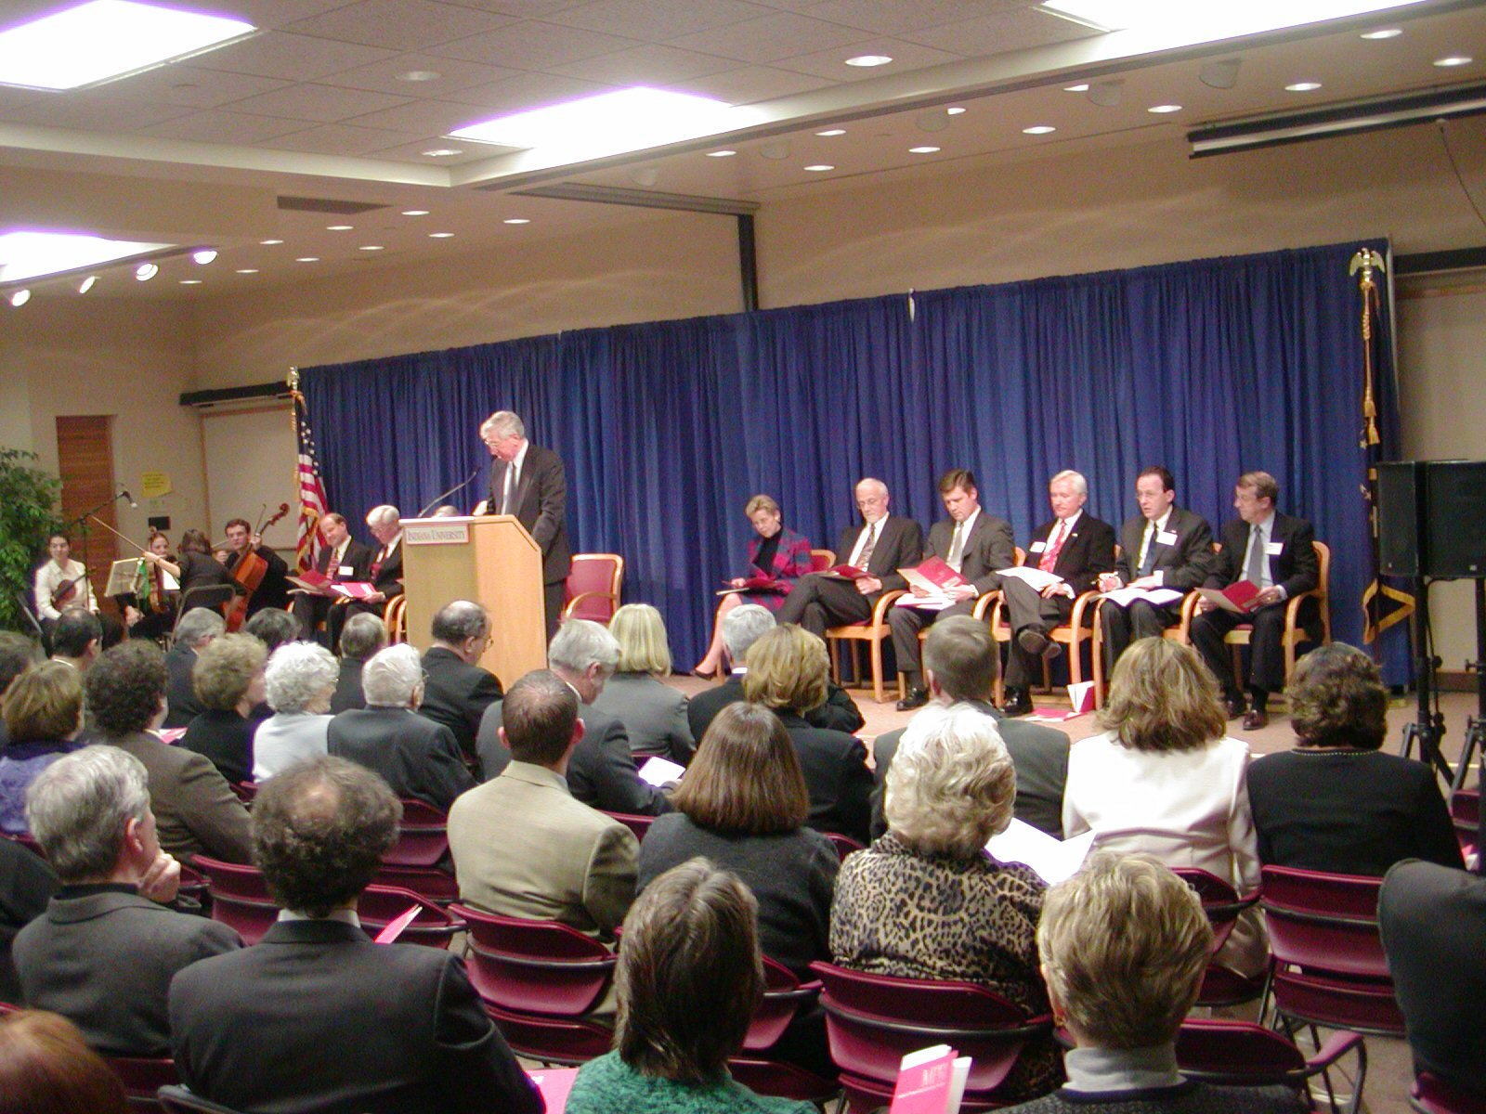
Figure 1: Indiana University President Miles Brand addressed the anticipated impact of MPRI on Indiana University at the MPRI Dedication Ceremony.
Speakers at the dedication ceremony included Dr. Jerry Slater, Dr. John Cameron, Dr. Allan Thornton, Mr. Lee Marchant, and Dr. Sharon Brehm, as well as President Myles Brand. Dr. Slater presented a unique perspective on the creation of Loma Linda University’s proton therapy center, from initial conception to recent promising statistical results. He expressed his enthusiasm for MPRI and other anticipated proton therapy facilities within the US. Dr. Cameron spoke of his satisfaction with a task well completed, praised the efforts of the IUCF staff, and expressed hopeful anticipation for the next phase of development. Lee Marchant of the Bloomington Economic Development Council (BEDC) related his experience during a visit to Boston where he observed proton therapy in operation. He was overwhelmed by the personal story of a young boy who was receiving treatments at NPTC during his visit. Supporting proton therapy in Bloomington became his passion. Dr. Thornton expressed his excitement about his future as the Medical Director of MPRI, proposed some therapies that might be offered and addressed some of the future directions he anticipated for MPRI. Dr. Brehm and President Brand accepted the keys on behalf of the University, with confidence that the relationship between MPRI and Indiana University would provide mutual benefits. The ceremony concluded with a reception held in the MPRI clinic.
Beginning in 2000, the proton therapy development group at IUCF designed and constructed a proton therapy facility that uses the existing 205 MeV cyclotron.

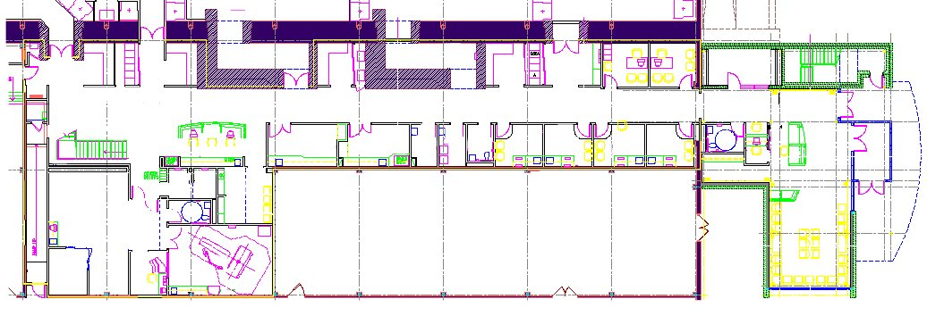
Figure 2: The MPRI floor plan, including two unfinished gantry treatment rooms.

A doubly achromatic beam line (the “Trunk Line”) was installed from the extraction port of the cyclotron, down the beam line corridor 190 ft. to the north wall of the existing building. One energy selection line (ES), designed for momentum band selection, was constructed 60 ft. from the cyclotron. This line leads from the Trunk Line to the first treatment room containing two fixed horizontal beam lines.

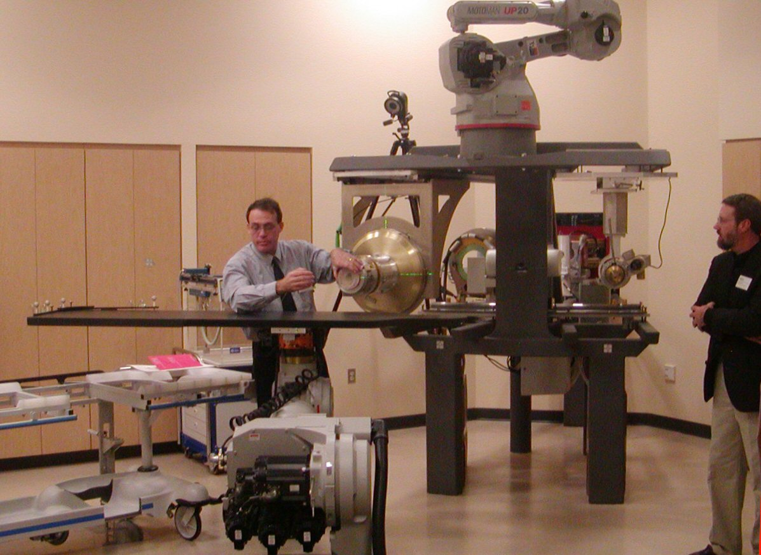
Figure 3: Niek Schreuder and Bill Starks in the Fixed Horizontal Beam Treatment Room, Treatment Room 1.

Two more ES lines are being fabricated and installed. Beam extracted from the Trunk Line is directed upon demand into the ES by a fast switching Kicker magnet. Final commissioning tests have begun on the treatment delivery systems for the Large Field Line in the first treatment room. Two gantries have been purchased from IBA, and construction of the second and third treatment rooms that will each house a gantry is underway. The treatment room mazes open out into the main corridor of the recently dedicated MPRI clinic.
The medical support facilities of the clinic are housed within the 4,800 sq. ft. IUCF “low bay” area. This 160 ft. linear distance is visually dissected by the incorporation of limestone block facades covering the maze enclosures and a large stairway/foyer topped with a skylight at the southern end. Warm paint colors were selected to produce a relaxing and comfortable environment. The nursing station is positioned for easy access to the examination rooms, imaging suite, recovery area, preparation rooms, and treatment rooms. A 1,720 sq. ft. reception area was constructed at the north end of the main corridor, providing MPRI patients with a private entrance and close-in parking. The medical physics workspace is located on the second floor, bridging IUCF and the MPRI foyer. Although completion of this space was scheduled as part of the second phase of construction, it has been finished ahead of schedule to facilitate the commissioning of the first treatment room.
The IUCF proton therapy development group is proud to announce the successful accomplishment of this project milestone, and we look forward to welcoming PTCOG to MPRI next year! Susan Klein, Indiana University Cyclotron Laboratory, 2401 Milo B. Sampson Lane, Bloomington, IN 474408.

Current status of proton therapy at University of Tsukuba
Since September 3, 2001 when the first patient was treated through May 2003, total 237 patients were treated at the new facility of Proton Medical Research Center, University of Tsukuba. Of the 237 patients 78 had hepatoma, 31 H&N cancer, 27 lung cancer, 26 prostate cancer, 25 metastatic tumors from various sites, 13 esophageal cancer, 9 brain tumors and the remaining 28 miscellaneous tumors.
In Fiscal Year (FY) 2002 (from April 2002 through March 2003) we treated 153 patients. For the patients total 2951 treatment sessions were given with an average of 19.3 sessions a patient. Of the 153 patients 104 were irradiated with proton beams alone and the remaining 49 with a combination of protons and x-rays.
In FY 2002 we planned to have 237 treatment days. Five days (2.1%) were lost due to the machine problems. Of the five days two were compensated on week ends. As a result the number of treatment days in FY 2002 was three days (1.3%) less than that planned.
No occurrence resulting in physical damage to a patient has occurred at our center.
When a number of treatment sessions given in FY 2002 (2951) were divided by the number of treatment days (234), an average number of patients (12.6) treated per treatment day in FY 2002 was obtained. Please note that we have been working with one shift and have not been working in a full capacity.
The facility has been operated with the following staff: (1) two operators for the accelerator (synchrotron); (2) three (full time) and a half (part time) radiotherapy technologists for two treatment rooms, a CT and an x-ray simulator; (3) a man manufacturing boluses using a NC machine; (4) four engineers or medical physicists, one of whom is assigned to supervise the operation each day; (5) seven radiation oncologists who are assigned to both conventional x-ray treatments and proton therapy as well as undergraduate and post graduate education; (6) five residents who are some times assigned to other departments in the hospital or other hospitals for their training; (7) one clerk for administration of the center and two part time secretaries.
We have a consultant who is a professor in accelerator technology at the High Energy Accelerator Research Organization. Since the patients are registered at the university hospital we have no staff for medical registration and accounting. We have no engineer from the manufacturer stationed at our center. However, when we have a major trouble with the machine, the engineers are called in a few hours.
When a maximum number of patients to be treated a day at two treatment rooms with two shifts is estimated based on our experience, I would say it might be about 70 patients. Six patients per hour can be treated at the two treatment rooms. Of the 16 hours 11 hours could be used for patient irradiation. For the remaining 5 hours, warming-up of the machine, and calibration of the dose (2 hours), and dose measurement for each new patient (3 hours) are done. When 6 patients are multiplied by 11 hours, a number of patients to be treated a day (66) is obtained. When a number of new patients a year to be treated at the two treatment rooms with the two shifts is estimated, it might be about 810 patients ((66 patients x 237 days)/19.3 sessions).
Although we still find minor and major problems with our proton therapy system from time to time, it has been functioning reasonably well. Yasuyuki Akine, Proton Medical Research Center, University of Tsukuba.

Proton Medical Facilities: what next? presented at PTCOG 39, May 2003.
The first few clinical proton medical facilities are now in use, and others are under construction. However, the accumulated experience with proton therapy in the clinical setting is less than 100 machine-years - whereas conventional photon therapy has some hundred thousand machine-years of experience behind it. It is not too surprising then to find that proton beam therapy has not yet achieved the level of performance of x-ray therapy. Moreover, while conventional therapy has a great deal of experience embedded in it, it is very far from reaching perfection.
There is a real need to improve the planning and delivery of radiation therapy in general, and of proton beam therapy in particular. In the following outline I have tried to identify areas in which I believe such improvements need to be made. I recently, with M. Jermann, analyzed the relative costs of proton and x-ray therapy [Goitein M and Jermann M. The relative costs of proton and x-ray radiation therapy. Clinical Oncology 2003 15:S37-S50]. However, the present comments are not comparative. They relate to where proton beam therapy needs improvement in absolute terms.

Goals of a Proton Medical Facility
I believe the following should be our goals:
- Deliver the highest possible QUALITY of proton beam therapy as SAFELY as feasible.
- Make THE MOST EFFICIENT USE OF HIGHLY TRAINED PROFESSIONAL STAFF.
- Do the above ROBUSTLY. That is, with excellent reliability, ease of operation, high availability and maintainability, and through providing extensibility for new options.
- Do all of the above AS INEXPENSIVELY AS POSSIBLE. This requires a balance between:
keeping the cost of the equipment as low as possible
keeping the cost of the equipment’s environment as low as possible
achieving the highest possible level of reliability, operability, maintainability and extensibility
keeping the cost of patient work-up, treatment planning and treatment delivery as low as possible
Obviously tradeoffs need to be made. For example, one will need to invest in equipment construction to reduce operational costs; it takes money to save money.

Quality of Proton Beam Therapy
Once one can deliver a set of Bragg peaks, each with its own intensity, location within the patient and direction of delivery, one has probably reached the limit of what can be achieved with protons. With beam scanning, we are very close to this point already. Having said this, the following need attention and additional development:
- reduction of the spot size (or penumbra) to as small a dimension as physics and technology allow
- use of special collimation techniques to further improve edge-definition
I would predict that, because of its ability to deliver Intensity Modulated Proton Therapy (IMPT) and the fact that it can always be tailored to deliver flat beams, spot or raster scanning will be routine within the next 5 to 7 years.

Safety
No design is “safe” in any absolute sense. One needs to design and build the equipment in such a way as to reduce the likelihood of safety problems to as low a level as feasible. This must generally be done in the context of a specific implementation. However, beam scanning is particularly vulnerable to dangerous failures and therefore the issue of the safety of scanning systems is of heightened concern. Therefore:
- I think it would be highly desirable for the proton community to develop, possibly under the aegis of PTCOG, some guidelines for proton beam scanning. These could address, for example, such issues as:
specification of the needed degree of redundancy
the requirement to keep delivery and monitoring functions separated
types of beam monitoring which would be desirable, including issues of the needed frequency of beam checking (within a spot, per spot, per “frame” etc.)
the need for repainting

Use of highly trained professional personnel
The quality of proton beam therapy, as with any other form of therapy, depends on human skills much more than it does on the tool itself. Quite apart from the question of their direct cost to a proton beam therapy program, highly trained professional personnel are a very scarce resource - and must not be abused. One cannot afford to tie up their time for longer than the technical needs of proton beam therapy absolutely require. So, for example:
- Clinicians must identify and delineate the target(s) and must edit and approve (but ideally not have to generate) the delineation of normal tissues - but new tools are sorely needed to minimize their effort in these tasks.
- Physicists must ensure the quality of the planning and delivery processes - but new tools are sorely needed to minimize their effort in these tasks. Long term stability and reliability can significantly reduce the frequency with which such checks have to be made.
- Dosimetrists will always have to plan treatments - but the tools needed for this should be fast. Semi-automation and high-level encapsulation (set up treatments from templates; trustworthy optimization, etc.) are needed.
If personnel are made to do unnecessary, time-consuming and/or uninteresting work they will become by stages dissatisfied and disinterested. If this happens, the quality of their work will suffer, as will the quality of the therapy.

Minimize overall cost
Many factors contribute to the cost of proton beam therapy (i.e. the cost per fraction). It is, of course, the overall cost which needs to be minimized, not each contribution separately.
Cost of the Equipment: Obviously, value engineering can reduce the production cost of the equipment. This, together with competition and efficiencies of scale should proton beam therapy come into greater demand, can achieve significant - but probably not enormous - reductions in cost. And, it could be that new technologies may bring important cost savings in the long run.
The size of the equipment - mainly the number of treatment rooms - has an important impact on its cost. Up to a certain point, the more rooms in a facility, the higher the capacity and the lower the cost/fraction. Unfortunately, this observation has led to probably unrealistic ideas of how big a proton medical facility should be. One should not minimize the risk of increasing the cost per fraction in the event that a large facility does not operate at capacity. A safer approach to increasing capacity is to improve the throughput of a smaller number of rooms.
Cost of the Building: Integration of the proton medical facility into an existing therapy facility and the sharing of infrastructure with the conventional radiotherapy service and with the broader hospital can save considerable costs.
Reliability, Operability, Availability and Maintainability, and Extensibility
Reliability, Operability. Maintainability and Extensibility are critical attributes of a proton medical facility. They can interact with one another; for example, increased reliability can affect availability and hence maintainability.
- robust design and redundancy (e.g. 2/3 logic…) can enhance both safety and reliability;
- intelligent control interfaces enhance safety and operability;
- good diagnostics, modular replacement and a wise spare parts strategy enhance availability and maintainability;
- good modular design enhances extensibility.
In general, there is a need to set high goals - and then to take them seriously.
Cost of pre-treatment work-up and treatment planning: The effort currently expended in the pre-treatment phase of proton beam therapy is enormous, and the process flow is highly inefficient. These components of proton beam therapy need a great deal of attention.
The main onus for advances in these areas is on treatment planning programs. They need much better capabilities for:
- image handling
- volume of interest delineation using semi-automatic tools
- plan design (e.g. use of templates)
- treatment prescription and archiving
The key “trick” is to make sure that the user is asked to do only those things which only the user can - and must - do.
Cost of treatment delivery: In current practice of proton beam therapy, the patient spends far too long in the room compared to the beam on-time. Typically, in current facilities, from 20 to 30 minutes are often scheduled for routine treatments. These inordinate times need serious attention. There is probably a factor of three improvement to be gained in this aspect of the process.
Summary
There is a huge need for improvement, and it is entirely feasible to achieve it, in:
- facility design
- equipment design leading to operational perfection
- process design
- planning design
Institutions planning to acquire or build a proton medical facility should not wait for equipment manufacturers to address these issues. Such institutions should take advantage of the power of the purse to address these issues with potential suppliers, and build requirements for them into their requests for proposals. By doing so they will get a superior machine for their pains, and will do a service to the field of proton beam therapy as a whole. Michael Goitein, Ankerstrasse 1, 5210 Windisch, Switzerland,

OncoLink: the largest website in the world for cancer information.

The website, at http://www.oncolink.upenn.edu currently gets 8 – 11 million hits per month making it one of the busiest healthcare sites in the world and an international resource for both physicians and patients. A dedicated section on proton therapy is being added to this website, which will certainly increase the visibility of proton therapy throughout the world. At the present time, this section is under construction and help is sought from all in the proton therapy community to make sure that we have the most pertinent, correct and up-to-date information as possible. Please visit the site, see what is there already and send me any comments or additional information. James. M. Metz, Editor-in-Chief, OncoLink, University of Pennsylvania, 3400 Spruce Street, 2 Donner Bldg, Philadelphia, PA 19104, Metz@xrt.upenn.edu.

PROTON THERAPY HISTORY

If you are interested in the history and development of proton therapy, you might like to visit the website http://phys4.harvard.edu/~wilson/cyclotron/history.html to read the current draft of the History of the Harvard Cyclotron Laboratory written by Prof. Richard (Dick) Wilson of Harvard University. Dick is a long time champion of proton therapy in general and of the Harvard Cyclotron Laboratory in particular. This document is still a work-in-progress but makes very interesting reading.
This history covers the different periods in the life of the Harvard Cyclotrons, starting with the first cyclotron at Harvard in the 1930s and continuing to the closure of the second cyclotron in 2001.

From the HCL archives: The cyclotron control panel over the years

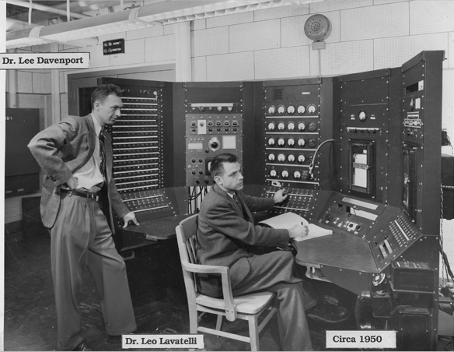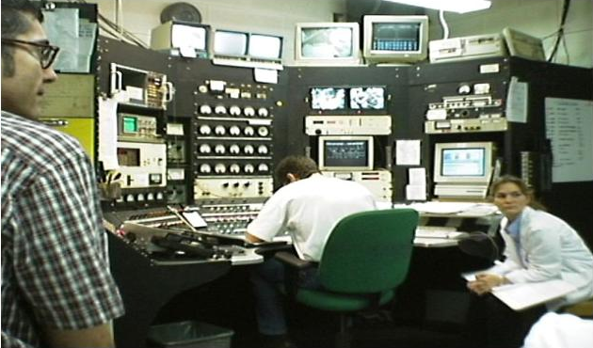
The original HCL control panel ~1950. The control panel in use for a patient treatment in the 1990s

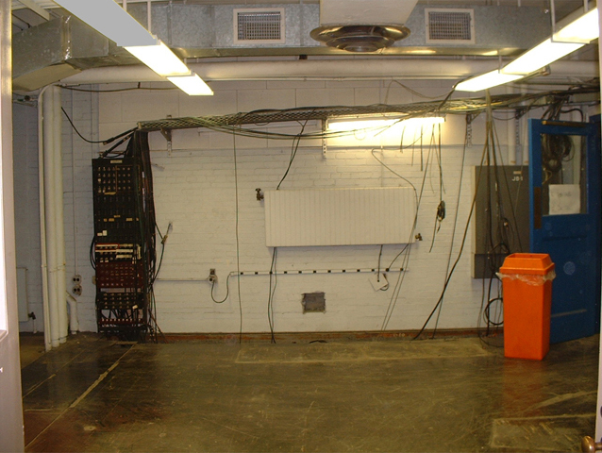
2001: Demolition of HCL is in progress, the control panel has been removed. It is hoped that the control panel will be displayed in the upcoming main exhibit of the Collection of Historical Scientific Instruments at Harvard University.

TREATMENT PLANNING SYSTEMS FOR PROTON THERAPY
July 2003
The following Table was originally presented in October 1999 by Skip Rosenthal, MGH at the Workshop on Treatment Planning Systems, PTCOG XXXI. Please send corrections/additions to Janet Sisterson.

Year | Created By | System Name | Status
1979-93 | LBL | LBL system | Not Available
1980 | MGH | Rx | Distributor MGH
1980 | MGH | EYEPLAN | Distributor MGH – EYES only
1990-96 | MGH/Seimens | V-Treat(AXIOM) | Not Available
198?,1991 | PSI | PSI system/Pion | Distributor PSI
1995 | DKFZ/Royal Marsden | Voxelplan/Proxelplan | Adapted by GSI, NAC, DKFZ
1996 | Radionics/MGH/HCL | P-Knife | Not Available
1997 | LLUMC/PerMedics | OptiRad 3D | FDA approved; commercial
1998 | Tsukuba | Hitachi system | In-house system
1998 | DKFZ | OCTOPUS | Under development – EYES only
1994 | Orsay/Curie | ISIS | Distribution ?
1998 | CMS/MGH | FOCUS | Commercial Release 1999
1998 | DKFZ | KonRad Plus Protons | Research Only
1989 – 2000 | CCO, Clatterbridge, UK | EYEPLAN v1.6 (VMS) | Available free;eyes only; research only
2000 | Varian | Polaris | FDA approved for passive treatment modalities
2001 | ITEP (Moscow) | ProGam | Adapted in PTF ITEP
2002 | MDS Nordion | Helax-TMS | FDA approved: commercial
2002 | CMS/Mitsubishi | FOCUS/M | Commercial Release 2001
 | RenderPlan |  | ?
 | Adac |  | ?
 | Michigan |  | ?

Proposed NEW FACILITIES for PROTON & ION BEAM THERAPY - July 2003

INSTITUTION | PLACE | TYPE | 1ST RX? | COMMENTS
IMP, Lanzhou | PR China | C-Ar ion | 2003 | C-ion from 100MeV/u at HIRFL expand to 900 MeV/u at CSR; clin. treat;biol. research; no gantry; shifted patients
Wanjie, Zibo | China | p | 2003 | Under construction. 230 MeV cyclotron, 3 gantry +1 horiz
PSI | Switzerland | p | 2004 | Addition of a 250 MeV cyclotron, 2nd gantry, new 1 fixed
Shizuoka Cancer Center | Japan | p | 2005 | synchrotron 235 MeV; 2 gantries; 1 horiz; funded.
Rinecker, Munich | Germany | p | 2005 | 4 gantries, 1 fixed beam, 250 MeV, scanning beams.
NCC, Seoul | Korea | p | 2005 | 230 MeV cyclotron, 2 gantries, 1 horiz, 2 research lines.
Heidelberg | Germany | p, ion | 2005 | 1 gantry; 2 fixed beam; p/carbon; int. contr. Raster scan
FPTI, U. of Florida | FL, USA | p | 2005 | 230 MeV cyclotron, 2 gantries, 1 fixed, 2 research lines.
IThemba LABS, Somerset West | South Africa | p | 2006 | 230 MeV, 1 gantry, horiz. + 30º beams, 1 horiz. + 15º beams
M. D. Anderson Cancer Center | TX, USA | p | 2006 | 250 MeV synchrotron; 3 gantries; 1 fix(2 beams)+1 exp rooms
Chang An Information, Beijing | China | p | 2006 | 230 MeV Cyclotron, under construction.
CGMH, Northern Taiwan | Taiwan | p | ? | 250MeV synchrotron/230MeV cyclotron;3 gantry,1 fixed
Bratislava | Slovakia | p, ion | 2003? | 72 MeV cyclotron; p; ions; +BNCT, isot prod.
Erlangen | Germany | p | ? | 4 treatment rooms, some with gantries.
CNAO, Milan & Pavia | Italy | p, ion | 2004? | synchrotron; 2 gantry;1 fixed beam rooms;1 exp. room
Med-AUSTRON | Austria | p, ion | 2007? | p gantry; 1 ion gantry; 1 fixed p with 2 lines; 1 exp room
Central Italy | Italy | p | ? | cyclotron; 1 gantry; 1 fixed
TOP project ISS Rome | Italy | p | ? | 70 MeV linac; expand to 200 MeV?
3 projects in Moscow | Russia | p | ? | including 320 MeV; compact, probably no gantry
Krakow | Poland | p | ? | 60 MeV proton beam.
Proton Development N.A. Inc. | IL USA | p | ? | 300 MeV protons; therapy & lithography
WORLD WIDE CHARGED PARTICLE PATIENT TOTALS
July 2003

WHO | WHERE | WHAT | DATE | DATE | RECENT | DATE
 |  |  | FIRST | LAST | PATIENT | OF
 |  |  | RX | RX | TOTAL | TOTAL
Berkeley 184 | CA. USA | p | 1954 | — 1957 | 30
Berkeley | CA. USA | He | 1957 | — 1992 | 2054 | June-91
Uppsala | Sweden | p | 1957 | — 1976 | 73
Harvard | MA. USA | p | 1961 | — 2002 | 9116
Dubna | Russia | p | 1967 | — 1974 | 84
Moscow | Russia | p | 1969 |  | 3638 | July-03
Los Alamos | NM. USA | π ⁻ | 1974 | — 1982 | 230
St. Petersburg | Russia | p | 1975 |  | 1029 | June-98
Berkeley | CA. USA | ion | 1975 | — 1992 | 433 | June-91
Chiba | Japan | p | 1979 |  | 145 | Apr-02
TRIUMF | Canada | π ⁻ | 1979 | — 1994 | 367 | Dec-93
PSI (SIN) | Switzerland | π ⁻ | 1980 | — 1993 | 503
PMRC (1), Tsukuba | Japan | p | 1983 | — 2000 | 700 | July-00
PSI (72 MeV) | Switzerland | p | 1984 |  | 3712 | Dec-02
Dubna | Russia | p | 1987 |  | 198 | June-03
Uppsala | Sweden | p | 1989 |  | 311 | Jan-02
Clatterbridge | England | p | 1989 |  | 1201 | Dec-02
Loma Linda | CA. USA | p | 1990 |  | 8203 | June-03
Louvain-la-Neuve | Belgium | p | 1991 | – 1993 | 21
Nice | France | p | 1991 |  | 1951 | June-02
Orsay | France | p | 1991 |  | 2157 | Jan-02
iThemba LABS | South Africa | p | 1993 |  | 442 | June-03
MPRI | IN USA | p | 1993 |  | 34 | Dec-99
UCSF - CNL | CA USA | p | 1994 |  | 448 | July-02
HIMAC, Chiba | Japan | C ion | 1994 |  | 1187 | Feb-02
TRIUMF | Canada | p | 1995 |  | 77 | Dec-02
PSI (200 MeV) | Switzerland | p | 1996 |  | 99 | Dec-01
G.S.I Darmstadt | Germany | C ion | 1997 |  | 172 | June-03
H. M. I, Berlin | Germany | p | 1998 |  | 317 | Dec-02
NCC, Kashiwa | Japan | p | 1998 |  | 200 | June-03
HIBMC, Hyogo | Japan | p | 2001 |  | 105 | July-03
PMRC (2), Tsukuba | Japan | p | 2001 |  | 237 | June-03
NPTC, MGH | MA USA | p | 2001 |  | 425 | July-03
HIBMC, Hyogo | Japan | C ion | 2002 |  | 30 | Dec-02
INFN-LNS, Catania | Italy | p | 2002 |  | 52 | July-03
Wakasa Bay | Japan | p | 2002 |  | 6 | March-03
 |  |  |  |  | 1100 | pions
 |  |  |  |  | 3876 | ions
 |  |  |  |  | 35011 | protons
 |  |  |  | TOTAL | 39987 | all particles

